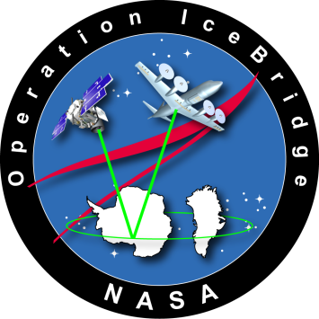

Science Flight Report
Operation IceBridge Arctic 2012

Flight: Falcon 02, 03
Mission: Greenland Interior (land ice)

Flight Report Summary

Aircraft | Falcon (HU-25) N525
Flight Number | Falcon 02, 03
Flight Log number | 12F001
Date | Monday, April 30, 2012 (Z)
Purpose of Flight | Operation IceBridge Northern Interior land ice mission
Take off time | 1124 Zulu from Thule Air Base (refueled at Thule,1500-1700 Z)
Landing time | 1900 Zulu at Thule Air Base
Flight Hours | 5.5 hours (3.5+2.0 hrs)
Aircraft Status | Airworthy.
Sensor Status | All installed sensors operational.
Significant Issues | None.
Accomplishments | - LVIS and photographic survey at 28,000 ft of ICESat lines over the northern Greenland ice sheet
Geographic Keywords | Northern Greenland
Satellite Tracks | Overflew historic ICESat lines
Repeat Mission | no
Science Data Report Summary
Instrument | Data Volume |  |  | Instrument Issues
 | Survey Area | Entire Flight
LVIS |  |  | 57 GB | None
LVIS cameras |  |  | 96 GB | None

Mission Report (Seelye Martin, Acting Project Manager)

This is one of the land missions for LVIS that the Land Ice Science Team ranked “High”. For this mission, the Thule weather office predicted clear skies for the flight except for scattered high clouds south of about 74 N. The nominal mission altitude was 28,000 feet. The mission took place in two flights, morning and afternoon. The morning flight had a length of 2,184 km; the afternoon flight; 1,889 km, each including transits. The total mission length was 4,073 km. The aircraft overflew portions of ICESat lines 32, 151, 166, 285 and 404, as well as a desired coastal trajectory. Preliminary examination of the camera and LVIS data shows that the instruments worked well.

Individual instrument reports from experimenters on board the aircraft:
LVIS: The LVIS system worked well and collected data for the majority of the flight. Few to no clouds were encountered along the data lines.
LVIS-cameras: worked well.

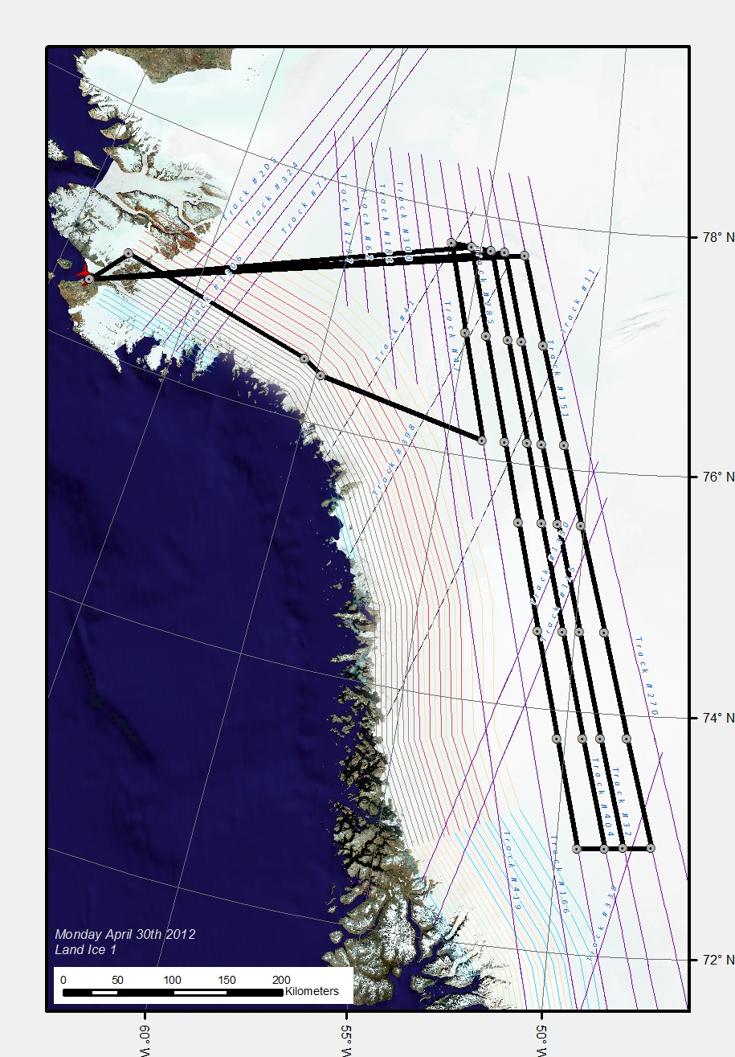
Figure 1: Mission lines overlain on historic ICESat lines. This shows the total results
of the morning and afternoon missions.

