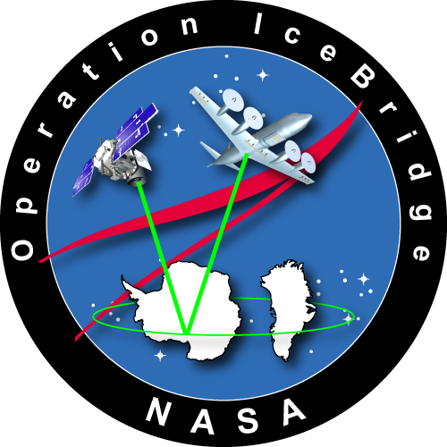
(Current as of Sep 2016)
[Earth Science Project Office, ESPO]
Orientation Package for Operation Ice Bridge – Antarctica.
http://www.espo.nasa.gov/oib/ Questions? Email: puq@espo.nasa.gov
Operation Ice Bridge

Table of Contents
Chile Entry/Exit Requirements 3
Punta Arenas, Chile 3
Car Rentals & Driving in Punta Arenas 3
Taxi Services 4
Lodging 4
Local Restaurants 4
Laundry Services 4
Pharmacies 5
Hospital and Health Insurance 5
Hardware Store 5
Money 5
General Travel Notes - Chile 5
Cell Phones & Communications 5
Electricity 6
OIB Operations 6
DC-8 Aircraft Location 8
Badging and Aircraft Access 8
Daily Mission Schedule 8
Office and Airfield Safety 8
Network and Communications 9
Office Equipment 9
Dialing Phone Numbers in Chile 9
Contacting ESPO 10

Welcome to Punta Arenas, Chile! This orientation package has been put together to help you become familiar with the Punta Arenas area and hopefully answer some of the questions you may have when you arrive. If you have any questions regarding the contents of this package, please do not hesitate to contact anyone in the Earth Science Project Office – ESPO.

Chile Entry/Exit Requirements
U.S. citizens entering Chile must have a valid passport, as of 2014 no visa nor reciprocity fee is needed for US citizens, stays are granted up to 90 days. An extension of stay for an additional 90 days is possible, but requires payment of an extension fee. U.S. visitors with red official passports need to have a visa on their passports, and such visas are processed by the civil servants’ respective Centers. Unless specifically requested, visas on official passports are usually for single entry and good if used within 90 days from the visa issue date. More up-to-date information about entry requirements for people from other countries can be found at their consular website: http://www.chile-usa.org/visasgral.htm

Punta Arenas, Chile
You will arrive at the Presidente Carlos Ibañez del Campo International Airport (PUQ). The airport is located about 20 Km (12 miles) north of the city of Punta Arenas. The airport is open 24/7. LATAM (previously known as LAN Chile until its recent merger with TAM airlines) is the primary commercial carrier to Punta Arenas, and they share the facilities with other small airlines such as Sky airlines, Aerovías DAP, and private planes. Punta Arenas is approximately 1400 miles south of Santiago. Even though the airport at Punta Arenas has customs and immigration offices you will probably go through these in Santiago. Punta Arenas can and will be very windy, wet and cold – Bring warm clothing. Also, Google maps provide very accurate and great visual information about the city. You (or your team) should coordinate for your own transportation from the airport to the hotel via car rental or taxi services (readily available at the airport.) Contact ESPO with any questions.

Car Rentals & Driving in Punta Arenas
- There are a few major rental car companies in Punta Arenas with locations at both, the airport and the city center:
  - Avis (operated by EMSA): Cell phone: +56 9 827-3113 laura@emsarentacar.com www.emsarentacar.com Address: Pedro Montt # 969 – Kuzma Slavic 706, Punta Arenas
  - Budget: Airport location, phone +56 61 212-293, downtown +56 61 202-721. After hours contact +56 99 444-0715. E-mail: budgetpatagonia@danilojordon.cl
  - Alamo: Airport location, phone +56 61 710-706. E-mail: punta_arenas@alamochile.com.
  - Hertz: Airport location: +56 61 210-096. After hours contact: +56 99-9195-3542. E-mail: hertzpatagonia@rentaaustral.cl.
- Parking in downtown Punta Arenas: A parking bill will be on your windshield when you return to your vehicle. Find and pay the city attendant (dressed in uniform with a handheld ticket/payment machine) on the street before you drive away. They take the license number off the car and charge you a fine with the rental company should you fail to make the payment before leaving.
- Visitors must have an international driver’s permit in order to drive legally in Chile. The international driver’s license must be obtained in the United States before traveling to Chile. Although car rental firms may rent to customers with only a U.S. driver’s license, the police fine foreigners for driving without a valid international permit. (Information taken from State Department web site.)

Taxi Services
- There are many taxies and taxi companies in Punta Arenas and they are almost always readily available when you need them. Their prices are very low by US standards (~5.00USD within the city limits.) Some of the companies include:
  - Radio Taxi Patagonia Austral, +56 61 226-908 or +56 61 22-930.
  - Radio Taxi Sur Competicion, +56 61 228-513 or +56 61 229-804.

Lodging
We will be staying at the Dreams del Estrecho Hotel (http://www.mundodreams.com/hotel/hotel-dreams-del-estrecho/) located on O’Higgins 1235, Punta Arenas, Chile, telephone +56 61 220-4500. The coordination for lodging has been ongoing prior to the deployment, the hotel is not holding any additional or backup rooms. If your lodging dates are incorrect or they change and you do not inform the hotel (and ESPO), you might end up without a room and will have to pay any incurring fees. If you do not check in on the scheduled date: your entire reservation will be canceled and you will be responsible for your own lodging arrangements (and pay the fees incurred in holding the room).
Upon check-in provide your payment information and ensure that your check-out date is accurate, please keep ESPO in the loop of any changes. The agreed room tariff is $139/night including breakfast, and wireless internet. Email ESPO for any questions.

Local Restaurants
There are a lot of good choices, many of which are on O’Higgins Street or on the Central Plaza, these include La Luna, Brocolino, O’Solemio for Italian, or La Tasca for Spanish. Try Lomito’s downtown for Chilean style sandwiches. For fine dining, try Sotito’s, Ganaderos, Puerto Viejo, etc. Ask the front desk for details.

Laundry Services
Aside from the hotel services –which are expensive- two other commonly used are On-Time in the Punta Arenas Mall and also Lavanderia Antartica, located on Jorge Montt # 664, telephone number +56 61 223-079, near the city center.

Pharmacies
Three Chilean chains are located throughout the city: Cruz Verde, Salco Brand, and Farmacias Ahumada. The Farmacia Ahumada located on Bories Street downtown is open 24/7.

Hospital and Health Insurance
You must coordinate with your Health Insurance provider to discuss coverage while in Punta Arenas. It is important to have this coordinated ahead of your arrival to avoid mistakes should an emergency or a need for medical attention arise. One of the options in Punta Arenas include the Clinica Privada Magellanes, near the Zona Franca, Av. Bulnes 01448, phone 21-1706-20-7349 or 23-0011-20-7356. For emergency ambulance, call 131.

Hardware Store
Sodimac, a store equivalent to the US Home Depot is located on the north end of town. Several electronic stores are located in the city center and also inside the Zona Franca.

Money
There are a large number of banks in Punta Arenas with 24/7 ATMs (cajero automático). Banks open at 9 and usually close by 2 or 3 pm. Beware of counterfeit bills (5000CLP and 10000CLP denominations). Also, look at and count the cash you hand out, since some bills look similar (e.g., 1000 and 10000 peso notes). The current exchange rate (09/22/2016) is about 671 Chilean Pesos (CLP) to the dollar.

General Travel Notes - Chile
- USG Per diem. $182/89 for Punta Arenas (effective since 09/01/2016).
- The sun is extremely bright, and very hot, due to the ozone layer conditions in this part of the Southern hemisphere. Bring sunscreen, sunglasses, etc.
- Keep a photocopy of your passport with you at all times. Please keep your passport safely stored. Hotels will ask for (or make) a copy of your passport when you check in.
- Outdoor clothing/goods. There is an excellent outdoor gear and clothing store, ALFGAL, about two blocks from the port in Punta Arenas. There is also a Northern Face store downtown.

Cell Phones & Communications
- Unless you have an international data plan, it is a good idea to disable the data roaming in your smart phones before you leave the US. The rate for data roaming is $20/Mb, so if by the time you land you have data roaming active and your phone automatically gets your email, auto-updates apps, or gets MMS messages with a couple of pictures, you could already have a very expensive phone bill waiting for you at home. Wi-Fi is available at most places including: the hotel, airport, cafes, and restaurants. Look for the Free Wi-Fi postings and ask the staff for the password.
- The ESPO's advance party will have local cell phones as well as our regular US phones available in Punta Arenas. We will distribute one local phone per team, these numbers will be posted in the OIB common area at the airport.
- Team members that want to purchase additional phones can do so by buying pre-paid cell phones for calls within Chile. These can be purchased for about $25 US, which includes $10 of calls. There are different cell phone providers such as Movistar, Entel, and Claro. Calls rates are about 60 CHP/min within network, 370 CHP/outside network.
- For personal communications with the US the best option is to use internet based apps (Skype, Tango, Whatsapp, etc) with the connectivity provided at the hotel, the airport, and many restaurants and cafes around town.

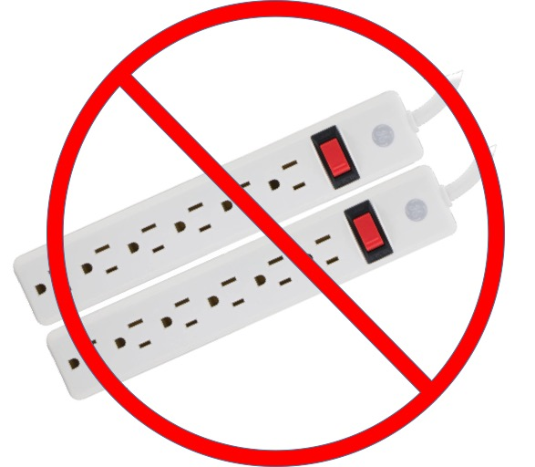
Electricity
Please note electrical power in Chile is 220V/50Hz. Please take care when plugging in your electronic devices. Bring a conversion plug with you from US to Chile. DO NOT PLUG US power strips/surge protectors into Chilean outlets, it will cause a short and possible damage to your equipment (plus the inconvenience of a power outage until airport personnel can restore power, which is very tricky, specially during weekends.)

OIB Operations
- The OIB operations area (the office) for OIB is located on the second floor of the DGAC (Dirección General de Aeronáutica Civil) building, directly adjacent (west) of the main terminal. The operations area provides a full view of the flight line and the parking lot.

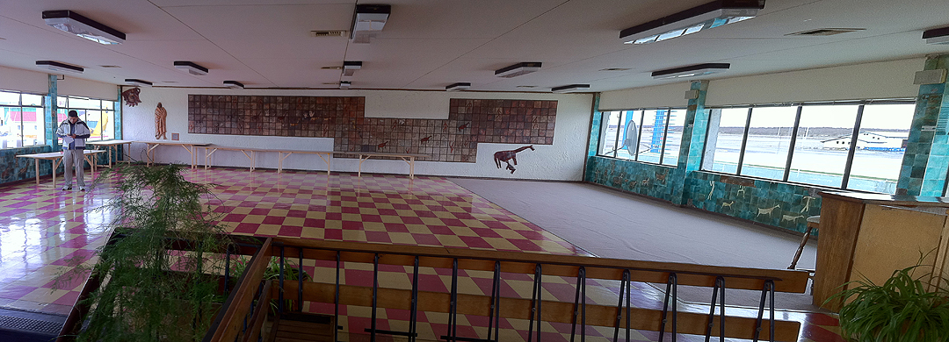
View of the OIB operations area before temporary modifications are added.

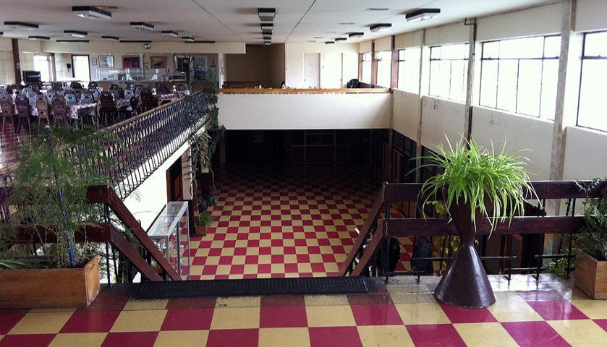
View of the cafeteria from the OIB operations area.

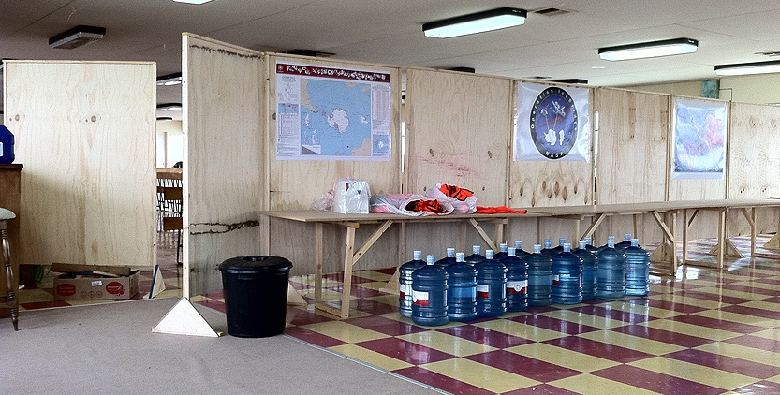
Privacy wall added to OIB operations area.

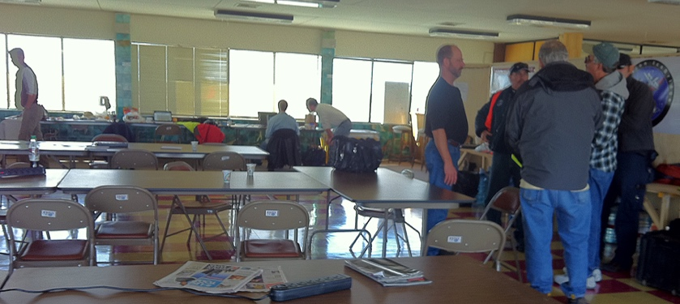
OIB in full operations mode.

- There are two ways to enter the ramp from our offices. One is via the airport Operations office (open 24/7). The other route (used for vehicles) is via an outside gate west of the old terminal. While it is supposed to be attended 24/7, it is a good idea to have the Operations office call AVSEC (airport security) to ensure that there is a person there to operate the gate.
- Parking is available across from the DGAC building. The exact amount for payment of parking fees is still being worked out, but the cost will be roughly $10USD per car per day.
- We have a single (shared) bathroom. Keys for the bathrooms will be in the ESPO Office. [We are working to get separate bathrooms that are open all the time.]

DC-8 Aircraft Location
The DC-8 will be parked on ramp parking location 5 (see picture) or in location 4, directly behind.

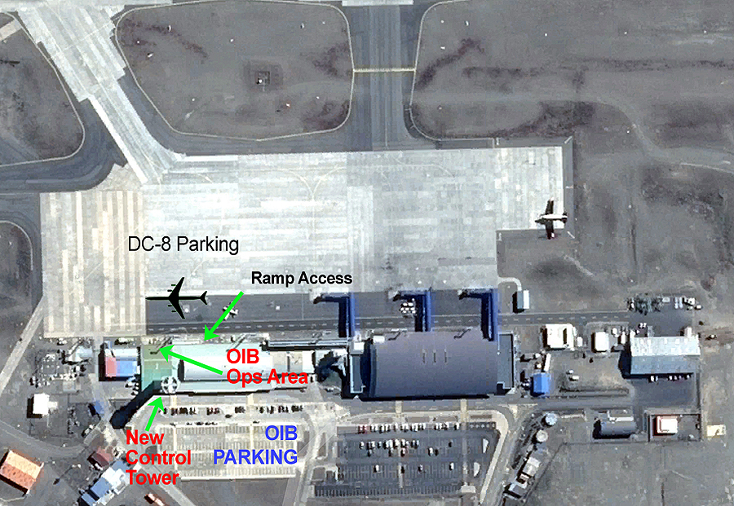
DC-8 location on the flight line. Indicated are also the location of the new control tower and office working space.

Badging and Aircraft Access
ESPO will handle badge arrangements for all OIB participants. An escort is not required for people walking from the office building to the aircraft UNLESS that person doesn't have a DGAC issued badge. Inform ESPO of ANY visitors to the operations area and/or aircraft. You must wear a reflective vest whenever you are on the ramp. It is extremely important. Always walk along the edge of the ramp and taxiway (noted on picture) and remain alert at all times. These are active areas of the airport and can be quite dangerous.

Daily Mission Schedule
Daily mission schedules will be emailed to OIB personnel and also posted on the ESPO Operation Ice Bridge website (http://www.espo.nasa.gov/oib/).

Office and Airfield Safety
- Use proper protective clothing when you are handling hazardous products/materials or performing tasks that would require additional protection (like LN2 refilling). Use appropriate hearing protection as needed.
- You are NOT allowed free roaming on the aircraft ramp even if you are badged.
- You MUST go directly to the aircraft from the office building door. These are strict rules that may not be violated at any time.
- No open-toed shoes (i.e., sandals) are allowed when working on the aircraft or walking on the ramp.
- There is no smoking on the ramp or taxiway.
- Be very aware of aircraft, extension cords and other trip hazards when walking to the aircraft.
- Keep your passport safely stored. Remember that passports are required for those who ride on the NASA aircraft.
- Always lock vehicles and keep personal items out of sight.
- If you want a couple of OIB related photographs loaded on the OIB web site please provide a digital image to a member of ESPO.
- The local equivalent to the “911” emergency line in Chile is:
  - 131 - AMBULANCE (SAMU)
  - 132 - FIRE DEPARTMENT (BOMBEROS)
  - 133 - POLICE DEPARTMENT (CARABINEROS)

Network and Communications
- ESPO will set up a wireless network in the OIB Operations area. Please remember that high-speed broadband communication in this remote part of the world is not always reliable and the bandwidth is usually limited and affected by wind conditions.
- Password will be provided on site.

Office Equipment
Printers, a copier and general office supplies will be supplied and available at the OIB Operations Center in the airport terminal.

Dialing Phone Numbers in Chile
For simplicity purposes we’ll assume that all the calls are being made to/from the USA. As a rule of thumb, you can always dial the number directly from your phone without any codes, if that fails, try the steps below.

International access codes (from the USA): 011, 00, and +. On some phones the plus (+) can be entered by just holding the 0 for a few seconds.

USA Country code: +1
Chile Country code: +56
Punta Arenas area code (land lines]: 612
Chile (Punta Arenas included) cell phone code: 8 or 9

To Dial Punta Arenas from International Locations:
The international access code varies from country to country. In the USA for example you can either use 011 [country code], or 00 [country code], or +[country code].

To dial a cell phone in Punta Arenas (or anywhere in Chile), from the USA, the following three ways of dialing are equivalent:

011 56 9 7391-7774 OR 00 56 9 7391-7774 OR +56 973917774

To dial a landline phone in Punta Arenas, from the USA, the following three ways of dialing are equivalent:

011 56 61 2 220-8800 OR 00 56 61 2 220-8800 OR +56 61 2 220-8800

Specific: (These may vary, check with provider.)
To call US from Chile cell: 123 - 1 - # (area code & phone #)
(or) To call US from Chile cell phone 18101 - # (area code & phone #)
To check Movistar account balance: *103 – SEND
To Check ENTEL account options: 301

Tip: It is a good idea to get in the habit of saving all of your contacts’ telephone numbers with the full format: +1 (234) 567-8910 even when in the US. While the smart dialing assistant (available on many phones) can take care of differentiating between a local call (when travelling abroad) and a call back to the US, dialing a number that is similar to a local number might result in dialing the wrong number.

Contacting ESPO
To Contact ESPO personnel in Punta Arenas, send an email to puq@espo.nasa.gov or use the local number: +56 9 9688-8264. The following is the time line of ESPO personnel in Punta Arenas:
Jhony Zavaleta | +56 9 9688-8264 | +1 650 224-4825 | Jhony.R.Zavaleta@nasa.gov | 10/3 – 10/22 & 11/10 – 11/22
Dan Chirica | +56 9 9688-8264 | +1 925 640-0463 | Dan.Chirica@nasa.gov | 10/9 – 10/29
Bernie Luna | +56 9 9688-8264 | +1 650 417-8810 | Bernadette.Luna@nasa.gov | 10/25 – 11/12

