## **Map from Antonio B. Won Pat International airport to Sheraton Laguna Guam Resort hotel**

470 Farenholt Avenue, Tamuning, Guam 96913

Phone (1)(671) 646 2222

* Turn left (west) and proceed towards Route 1, Marine Corps Drive.
* Turn left onto Route 1 and continue south for approximately 2 miles.
* Turn right onto Gov Carlos G Camacho Road.
* Turn left on to Farenholt Avenue after approximately one mile. Farenholt Avenue will lead directly to the resort.

Approximately 10 minutes

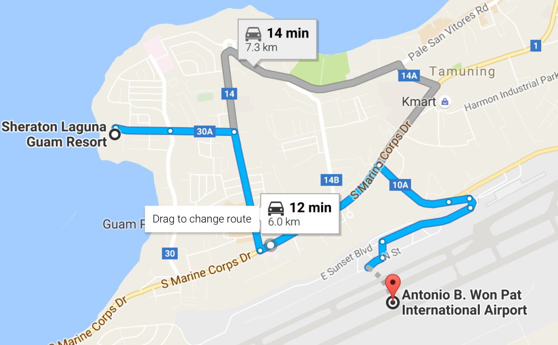

**Map from hotel to United Hangar - Approximately 20 minutes**

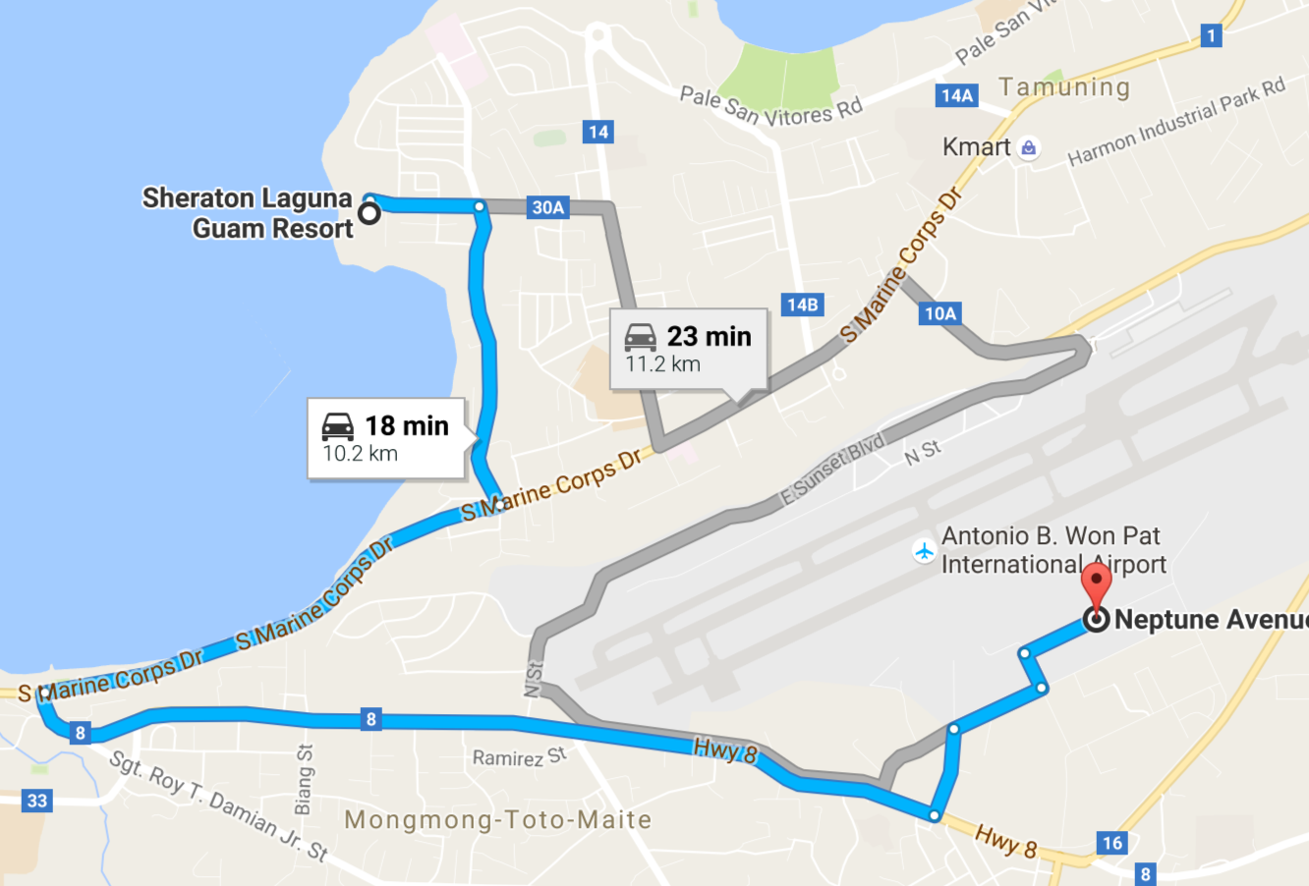

Head east on Farenholt Ave toward Condo Ln

Turn right onto Route 30 (Gov Carlos G Camacho Rd)

Turn right onto Highway 1 (S Marine Corps Dr)

Turn left onto Route 8

Turn left at the 4th stop light (Admiral Sherman Boulevard)

You’ll pass a Guard Shack that says Welcome to Tiyan

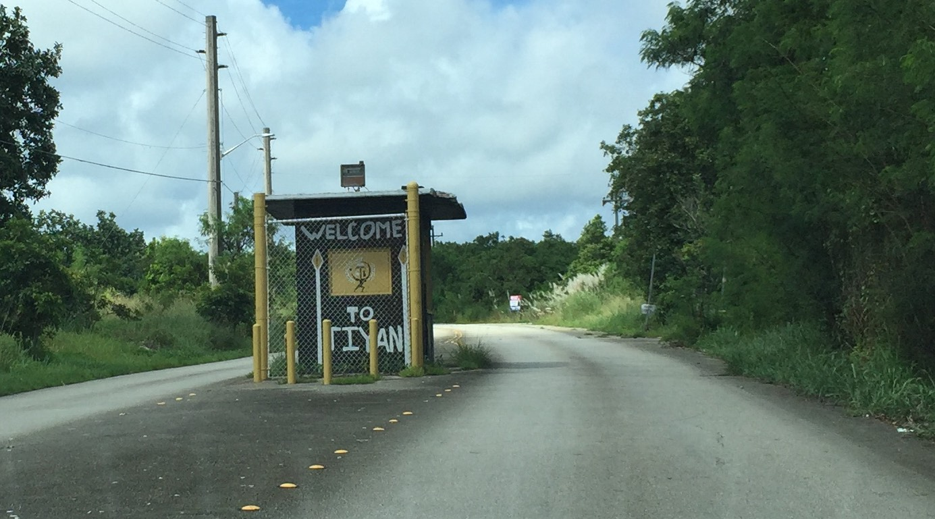

Turn right at the stop sign (Mariner Ave)

Turn left on Corsair Ave (where there is a United Hanger sign)

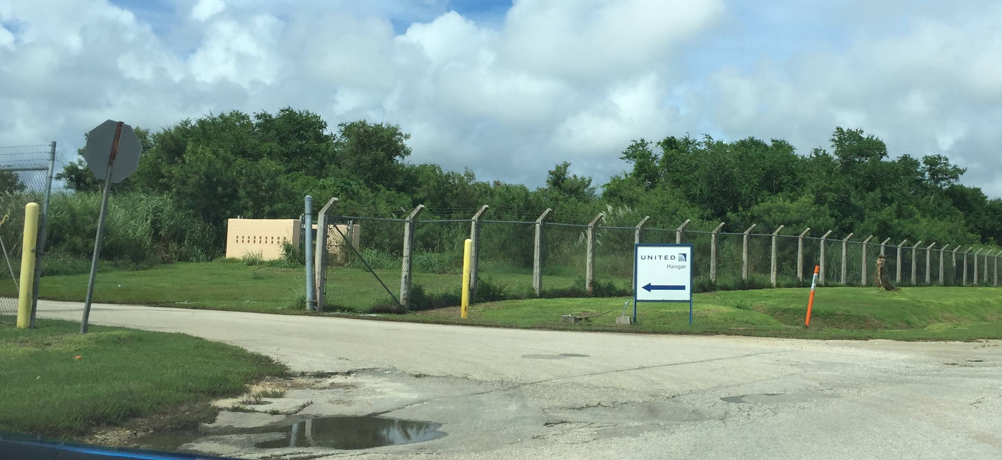

Take the first right onto Neptune Ave

United Hangar is on the left half-way down the street.

You'll see a NASA banner on the fence where you can turn in to park near the United Hangar

