**Introduction to the KORUS-AQ Rapid Science Synthesis Report**

Under the leadership of Korea’s National Institute of Environmental Research (NIER) and the United States National Aeronautics and Space Administration (NASA), the Korea-United States Air Quality Study (KORUS-AQ) assembled a large team of measurement and modeling experts to conduct a field study in Korea. The overarching goal of this study was to improve our understanding of the factors contributing to poor air quality in Korea. The KORUS-AQ study collected detailed measurements from aircraft, ground sites, and ships during May and early June of 2016. Observations were guided by model forecasts of meteorology and air quality, but they also serve to evaluate the performance of these models as part of the ongoing analysis of KORUS-AQ data.

The detailed report that follows provides a set of high level findings that are intended to be useful for policy makers to consider in the development of air quality mitigation strategies and the identification of specific emission sources that should be targeted for reduction.

The KORUS-AQ study provided unprecedented comprehensive measurements of pollutants (both trace gases and aerosol particle properties) with extensive spatial and vertical coverage. It is important to recognize that the brief KORUS-AQ measurement period is insufficient to address all of the air quality issues confronting Korea, thus we provide this introduction to summarize both the value and limitations of the KORUS-AQ observations.

**Air quality in Korea consists of both visible and invisible components of pollution which need to be addressed.**

Air quality in Korea is monitored for six pollutants: PM10, PM2.5, O3, NO2, SO2, and CO. Of these, PM10 associated with dust transport is the most visible to the public, which understandably generates the most attention and outcry for improving air quality conditions. PM10, however, is not effectively transmitted into the lungs (see Figure 1). By contrast, particles smaller than 2.5 microns and O3 can pass much more easily and deeply into the lungs and thus present much greater threats to public health and respiratory problems.

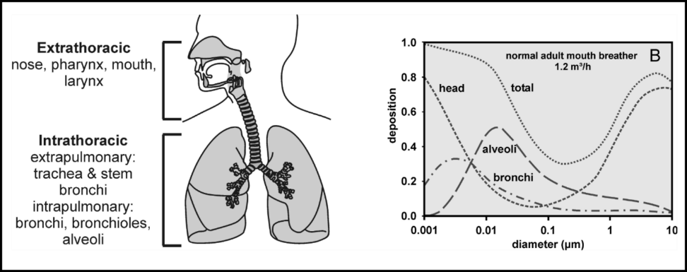

Figure 1. The respiratory tract and particle deposition in a normal adult mouth breathing male human subject at rest, as a function of particle size. Bronchi data represents the sum of bronchi and bronchioles.

Taken from Geiser and Kreyling (2010).

From a public awareness perspective, visible light scattering by particles to judge air quality conditions is imperfect at best since the amount of scattering is a complex function of humidity and particle properties such as size, shape, and composition. For O3, the visible cues are much more subtle, preventing the average person from knowing whether unhealthy levels are present in the air. Thus, measurements by the AirKorea network and increased public awareness of their interpretation regarding the differences between PM10, PM2.5, and O3 is essential to put increased attention on the aspects of air quality most important to public health.

**The KORUS-AQ observation period was specifically chosen to target local photochemical pollution which peaks in May-June rather than pollution transport which tends to be greatest in March-April.**

While springtime transport is an important problem, these episodic events include both dust and pollution from sources outside Korea that complicate the interpretation of PM2.5 episodes and the contribution from local sources. In contrast, photochemical processing of local emissions tends to peak over the Korean peninsula in the May-June time period when warmer temperatures, higher humidity, longer days, more intense sunlight, and increased emissions from vegetation can all serve to accelerate the sunlight-driven photochemistry contributing to formation of both O3 and PM2.5. Thus, the rationale for conducting KORUS-AQ in May-June was based on the potential for observing violations of air quality standards for both O3 and PM2.5 and the expectation that local sources would play a greater role in determining observed O3 and PM2.5 abundances. Along with detailed observations of precursors for O3 and PM2.5, KORUS-AQ enables an in-depth analysis of the complex chemistry and contributions of different sources (e.g., transportation, power generation, industry) needed to enable informed decisions on how to best target emission controls to improve Korean air quality and set expectations on what can be achieved based on local regulations alone.

**Air quality standards were exceeded for both ozone and PM2.5 during the KORUS-AQ time period.**

During KORUS-AQ, AirKorea monitors documented extended periods of O3 pollution in violation of Korean air quality standards. PM2.5 standards were also exceeded during a one week period in late May (see Figure 2). KORUS-AQ observations were made during a wide range of conditions including those that led to these events. The level of detail afforded by airborne observations and augmentation of ground sites such as Olympic Park and Taehwa provide the information needed to unravel the details of these pollution events and their contributing factors. These observations and their analysis form the basis for the findings of this report.

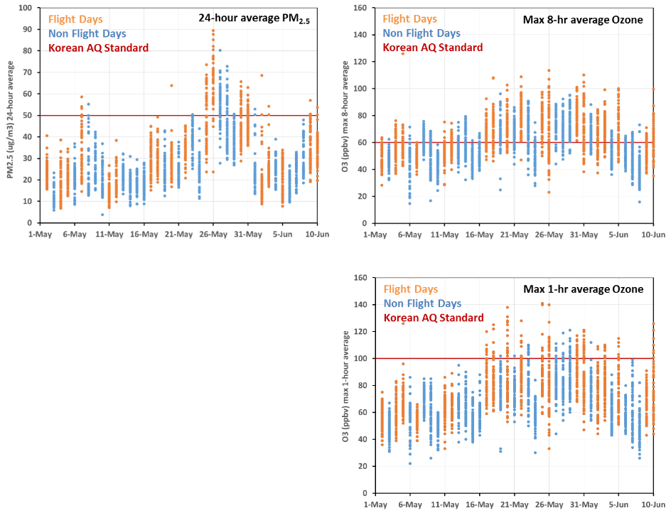

Figure 2. Observations of PM2.5 and O3 from selected AirKorea monitors in Seoul, Busan, and Gwangju during the KORUS-AQ field study period of 1 May-10 June 2016. Observed values across individual ground sites on each day are compared with Korean air quality standards. Days of airborne data collection are shown in orange showing that flight days adequately sample the range of air quality conditions. (Figure provided by Jim Crawford, NASA)

**Local emissions play a significant role and are often sufficient to create air quality violations, but transboundary pollution must be considered as an exacerbating factor.**

As will be shown in this report, local emissions in Korea are substantial. In particular, the abundance of local nitrogen oxide emissions combined with highly reactive organics (e.g., toluene) that are too short-lived to survive transboundary transport are critical to sustaining the high O3 observed throughout the KORUS-AQ time period. Additionally, the high background levels of O3 in east Asia amplify this problem. Similarly, there is evidence for substantial local production of secondary particulate pollution, however, the PM2.5 air quality violations observed during KORUS-AQ occurred during a period of enhanced direct transport from east Asia. This demonstrates that the combination of local and upwind sources lead to the worst conditions for particulate pollution. A more detailed look at these factors as seen through the KORUS-AQ observations is contained in the report.

**Comparing the KORUS-AQ period with other years and other seasons is needed to put the observations into perspective.**

Much of the variability in air quality conditions is driven by meteorology, which can differ considerably from year to year. During most of the KORUS-AQ time period, influence from east Asia and China was generally weak. This was beneficial for isolating the influence of local emissions on air quality in Korea. Direct transport from China was only observed during one short period from 25-28 May. Local influence of Korean emissions was maximized during a stagnant period from 17-22 May. The atmospheric flow patterns during these two periods are contrasted in Figure 3.

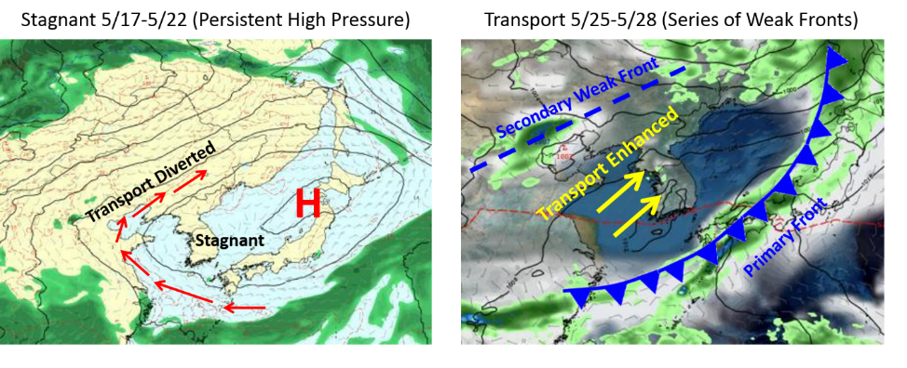

Figure 3. Contrast in meteorological conditions observed during KORUS-AQ in the transition from stagnant conditions over the Korean peninsula (left) to a period of direct transport of air from upwind source regions in China (right). (Figure provided by David Peterson, NRL)

The meteorological conditions during KORUS-AQ were very favorable for understanding how local emissions contribute to the local air quality problems. This has enabled findings that will be useful for identifying strategies for reducing emissions that are most likely to lead to improved air quality. Over time, however, actual conditions will be influenced by year-to-year differences in meteorology and seasonal differences in long-range transport. In this regard, the KORUS-AQ timeframe and associated observations provide a critical benchmark for comparison. Continued work will be necessary to fully evaluate the degree to which emissions reductions are being successful within the interplay between air quality and meteorology in future years.

**Questions addressed by this report of preliminary findings**

This report is organized into five chapters, each addressing a specific question for which KORUS-AQ observations provide insight. While these findings are preliminary, they are considered to have a high level of confidence. Nevertheless, continued scientific analysis is needed to better quantify these findings. These additional analyses will be published in peer-reviewed scientific journals over the next few years, but should not cause delay in discussing strategies for emission reductions and their potential for improving air quality in Korea.

The questions are as follows:

1. **Can we identify a) the portion of aerosol derived from secondary production in SMA and across Korea, and b) the major sources and factors controlling its variation?**
2. **Is ozone formation in Seoul NOx limited or VOC limited? Can we determine the biogenic or natural contributions to ozone production?**
3. **How well do KORUS-AQ observations support current emissions estimates (e.g., NOx, VOCs, SO2, NH3) by magnitude and sector?**
4. **How significant is the impact of the large point sources along the west coast to the air quality of SMA temporally and spatially?**
5. **How is Seoul affected by transport of air pollution from sources from regional to continental to hemispheric scales?**

**Question 1: Can we identify a) the portion of aerosol derived from secondary production in SMA and across Korea, and b) the major sources and factors controlling its variation?**

**Summary Finding: Secondary production accounted for more than three-quarters of fine particle pollution observed during KORUS-AQ. Overall composition is dominated by organics, but sulfate and nitrate still comprise nearly half of the secondary aerosol mass. Local gradients and correlations between fine aerosol and other chemical indicators suggest that local sources make a dominant contribution to secondary aerosol production. Thus, any reductions in emissions of VOCs, NOx, SO2, and NH3 would be expected to contribute to reductions in PM2.5.**

Understanding the factors controlling fine particulate pollution in Korea is a high priority. During the KORUS-AQ period, PM2.5 for AirKorea monitors across SMA averaged 28 µg m-3. While this value is modest compared to other times of year when particle pollution is much worse, those periods can be heavily influenced by transported pollution from outside Korea, complicating interpretation of local versus upwind influences. During KORUS-AQ, conditions were dominated by local sources for much of the time, offering the opportunity to evaluate local precursor emissions and place realistic bounds on the levels of associated particle pollution levels that they can sustain.

Understanding the various sources of particulate pollution begins with aerosol composition measurements. Such measurements were collected from the air and the ground during KORUS-AQ for fine particle pollution (PM1) using aerosol mass spectrometers and are shown in Figure 1-1.

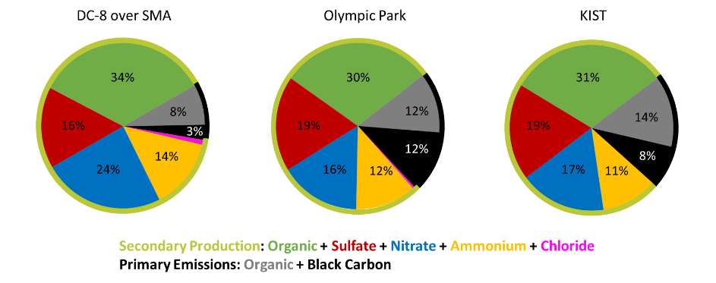

Figure 1-1. Average composition of fine particle pollution observed during KORUS-AQ from the DC-8 and two ground sites in Seoul. (Figure provided by Ben Nault, University of Colorado-Boulder; Hyejung Shin, NIER; and Hwajin Kim, KIST)

The composition measurements in Figure 1-1 compare well with each other and indicate that fine particle pollution is dominated by particles smaller than 1 micron given that the average mass loadings that were observed are also similar to the average AirKorea PM2.5 value of 28 µg m-3. This gives confidence that these measurements are representative of particle composition across SMA. The composition data are grouped into two major categories, secondary aerosol and primary emissions. Secondary production represents the dominant component of particulate pollution at more than 75% with direct emissions of primary particle pollution at 25% or less across the measurement locations. Primary emissions contribute less to composition above the ground as seen from the DC-8 compared to the ground sites, but this is consistent with dilution of surface emissions as they are mixed into the lower atmosphere. By contrast, secondary production occurs both at the ground and aloft.

Nitrate aerosol is the component with the strongest signature of local production, which is not unexpected given the large NOx emissions from vehicular traffic in SMA and power plants along the northwest coast. This is shown in Figure 1-2 where nitrate in excess of 10 µg m-3 is limited to the northwest portion of the Korean peninsula in the KORUS-AQ observations from the DC-8. Additionally, these nitrate abundances make a large contribution to aerosol mass that can be as much as 30-40% and 10-30 µg m-3.

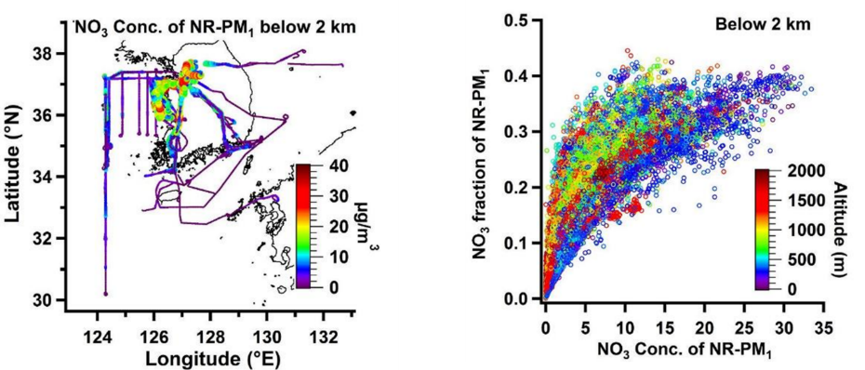

Figure 1-2. Map of aerosol nitrate concentrations in the lower atmosphere below 2 km observed from the DC-8 (left) and the fraction of fine particle pollution attributable to nitrate as a function of nitrate concentration (right). (Figure provided by Taehyoung Lee, HUFS)

Evidence for local production of the organic component of fine particles is also seen in the correlation of organic aerosol with formaldehyde and the abundance of Ox (O3+NO2) shown in Figure 1-3. Formaldehyde is a result of the breakdown of organic molecules and provides an excellent indicator of integrated oxidation of VOCs contributing to organic aerosol formation. In SMA, toluene and other aromatic compounds are a dominant contributor to this chemistry. As will be discussed further in this report, these aromatic compounds also contribute to ozone formation and play a disproportionate role in SMA VOC chemistry. Correlation with NO2+O3 shows that organic aerosol generally scales with oxidation potential, thus the amount of aerosol formation is closely tied to the intensity of local chemistry.

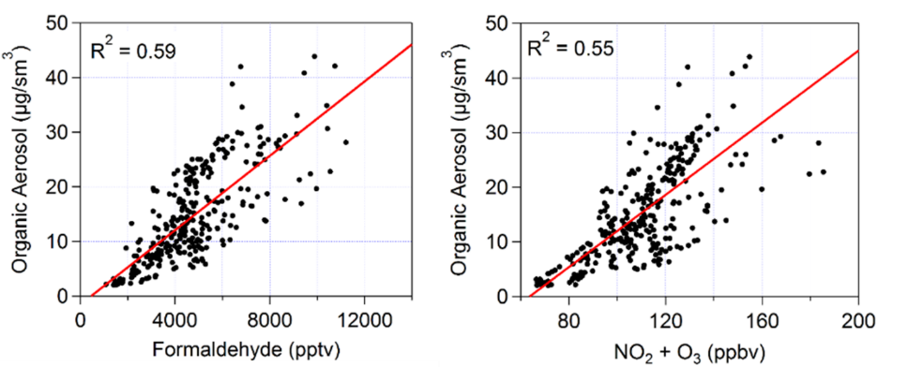

Figure 1-3. Correlation of organic aerosol with photochemical indicators, formaldehyde (left) and NO2+O3 (right) in afternoon observations by the DC-8 over Seoul. (Figure provided by Ben Nault, University of Colorado-Boulder and John Sullivan, NASA)

Given that the organic and nitrate components account for roughly half of the aerosol mass (see Figure 1-1), there is a high potential for reductions in local formation of secondary particulate pollution through both VOC and NOx control strategies. These two precursors are also critical to the control of ozone pollution and will be discussed in more detail in the next section. Thus, there is the opportunity for dual benefits in controlling VOC and NOx emissions.

Ammonium is another component of fine particulate pollution that is worthy of additional attention. Unfortunately, gas phase ammonia was not measured during KORUS-AQ, but the abundance of ammonium shown in Figure 1-1 is sufficient to neutralize the sulfate and nitrate, indicating an excess of ammonia available for secondary aerosol formation. In the future, ammonia measurements would be important to establish how much emissions would need to be reduced for ammonia to become a limiting factor in secondary aerosol formation.

**Question 2: Is ozone formation in Seoul NOx limited or VOC limited? Can we determine the biogenic or natural contributions to ozone production?**

**Summary Finding: In Seoul, ozone formation is VOC limited, due to an overabundance of NOx. A detailed assessment of VOC contributions to ozone formation indicates that reactive aromatics, toluene in particular, make a dominant contribution to ozone formation. Better identification and targeting of aromatic emission sources should be a priority. Despite the VOC-limited environment in Seoul, the very high abundance of NOx in the city poses a problem for ozone formation across the greater SMA and Korea as the dilution of NOx acts to increase the efficiency of ozone production which is further aided by VOCs from biogenic sources. This calls for reductions in both VOCs and NOx. Unlike PM2.5, which will immediately benefit from emission reductions, ozone in some areas may worsen in the short term due to the very high NOx levels and nonlinear efficiency of ozone production.**

Understanding the drivers of ozone formation is challenging and requires combining observations with modeling to determine how to reduce ozone pollution. Ozone does not depend linearly on NOx and VOCs, so an identification of whether ozone formation is NOx-limited or VOC-limited does not by itself indicate how to best reduce ozone levels. During KORUS-AQ, DC-8 flights took advantage of a natural gradient in NOx and VOCs by repeatedly overflying ground sites at Olympic Park in Seoul and Taehwa Research Forest located ~30 km to the southeast on many different days and under different conditions.

A summary of these DC-8 observations is shown in Figure 2-1, contrasting the two sites in the morning, midday, and afternoon. The most noticeable difference is that NOx mixing ratios are much lower at Taehwa than in Seoul at all times of day with median values that were 2-6 times lower at Taehwa. NOx levels are lower outside the city due to dilution of the primary emissions as well as chemical processing. As noted earlier, formaldehyde is an excellent proxy for VOC chemistry as it is a common product of their chemical breakdown. In this case, CH2O is very similar between the two sites, and roughly constant throughout the day. This suggests that continued oxidation of VOCs and additional emissions from vegetation sustain CH2O values downwind of Seoul. Finally, ozone increases steadily from morning to afternoon at both sites, but for each time period Taehwa has higher amounts by ~20 ppbv.

The bottom right panel in Figure 2-1 shows net ozone production rates that have been calculated with the NASA LaRC Photochemical Box Model which has been constrained by the observations on the DC-8 aircraft. The highest rates of net ozone production at both locations occur during midday, when photochemistry is most active (i.e., highest sun angles). Despite the large differences in NOx, one of the primary drivers of ozone formation, the rate of net ozone production is very similar over Seoul and Taehwa. This demonstrates that ozone production across SMA is VOC-limited (NOx-saturated).

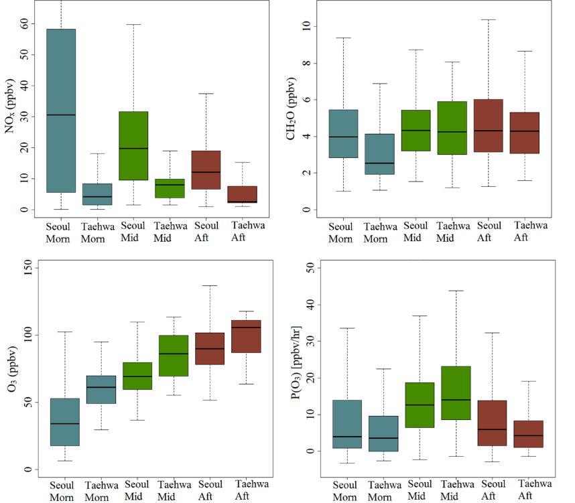

Figure 2-1. Distributions of measured NOx (top left), formaldehyde (top right), and ozone (bottom left) from DC-8 observations below 500 m over Seoul and Taehwa Research Forest for morning, midday, and afternoon overflight times. Boxes show median and inner quartile values and lines show 5th and 95th percentile values. The lower right panel shows the resulting distribution of net ozone production rates resulting from box model calculations constrained by the DC-8 observations. (Figure provided by Jason Schroeder, NASA)

To better understand the sensitivity of ozone production to VOCs, additional box model calculations were conducted to quantify the chemical response when eliminating various classes of VOCs. Figure 2-2 shows the ozone production rates using the complete suite of DC-8 observations compared to calculations where a single hydrocarbon or a group of VOCs are removed from the model simulation. C7+ Aromatic compounds (which include toluene, benzene, ethylbenzenes, xylenes) are shown to have the greatest impact on ozone production by far. When these compounds are removed from the calculation, the distribution of ozone production rates drop from 10-60 ppbv/hr to less than 10 ppbv/hr. Isoprene is the other compound that has a measureable impact on ozone production while other VOCs have negligible effect. An important distinction between C7+ Aromatics and isoprene are their sources. Given their industrial sources, C7+ Aromatics provide an attractive target for reductions that will benefit ozone (as well as fine particle) pollution. By contrast, the natural source of isoprene from vegetation has to be considered when monitoring ozone chemistry response to reductions on NOx and aromatic VOCs, but it does not offer an effective target for emissions reduction.

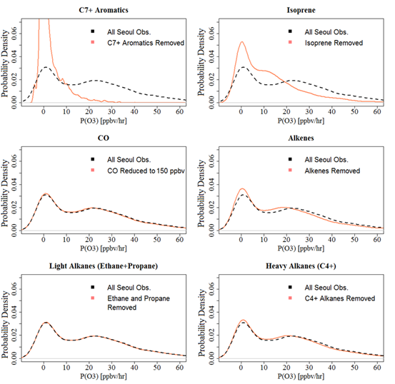

Figure 2-2. Sensitivity of net ozone production to different VOC classes. In each panel, the black line indicates the distribution of net ozone production rates calculated from the complete suite of DC-8 observations over Seoul. Orange lines indicate the change in calculated values when the removing a specific class of VOC. (Figure provided by Jason Schroeder, NASA)

While reductions in C7+ aromatics will benefit local ozone production in Seoul, there is still the problem of downwind ozone production. The higher levels of ozone at Taehwa (see Figure 2-1), despite the lower concentrations of NOx, highlights the regional impact that the very high NOx in Seoul has on sustaining ozone production downwind and across the surrounding region. More broadly, a comparison of ozone during KORUS-AQ across the AirKorea network in the greater SMA (Gyeonggi) versus Seoul (not shown) indicates that Gyeonggi violates the 1-hour daily maximum ozone standard at nearly twice the rate of Seoul and average daily maximum 1-hour ozone abundances are greater by more than 10 ppbv (74 in Gyeonggi versus 62 in Seoul). Thus, despite the large gradient in NOx from inside Seoul and into the surrounding region shown in Figure 2-1, conditions remain NOx-saturated over a very large area and the only way to limit the regional extent of ozone production is to also target NOx emissions for reduction.

It is important to recognize that ozone chemistry is nonlinear in its response to changes in NOx. Thus, while NOx reductions will reduce the regional extent of ozone production, the benefits of reducing aromatic VOCs will be partially offset by more efficient ozone production in certain areas as NOx controls are introduced. To understand this nonlinearity, it will be helpful to have as much detail as possible on the distribution of NOx and CH2O across SMA and the Korean peninsula. The hourly information provided by the GEMS satellite will be a powerful tool for monitoring this progress. This is demonstrated in Figure 2-3, which shows the distribution of NO2 across SMA as seen from the NASA B200 aircraft on the afternoon of 9 June 2016. These observations were taken by the Geo-TASO instrument, an airborne instrument similar to GEMS. Evident in the image is the strong gradient from high concentrations of NO2 in the urban areas to low concentrations in surrounding areas. Combined with observations of CH2O, the GEMS satellite observations will provide important details on the changing intersection between NOx and VOCs.

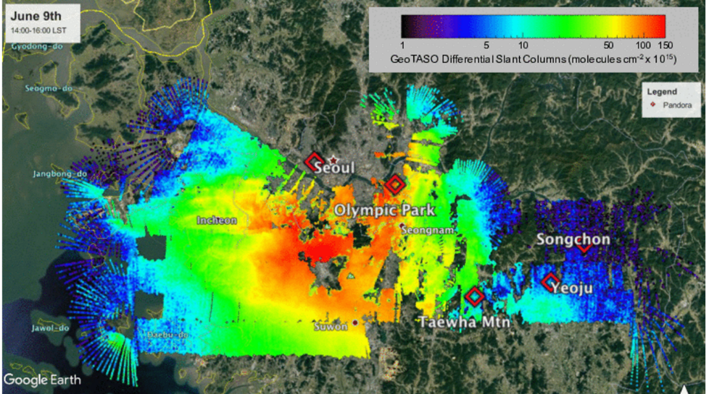

Figure 2-3. NO2 distribution across SMA as observed by the Geo-TASO instrument from the NASA B200 aircraft on the afternoon of 9 June 2016. Geo-TASO is an airborne instrument similar to GEMS. Mapping of slant column densities was accomplished over a two-hour period. (Figure provided by Laura Judd, NASA)

An important issue influencing efforts to reduce ozone at the surface is its abundance in the greater atmosphere above Korea demonstrated by the vertical distribution of ozone during the KORUS-AQ study shown in Figure 2-4.

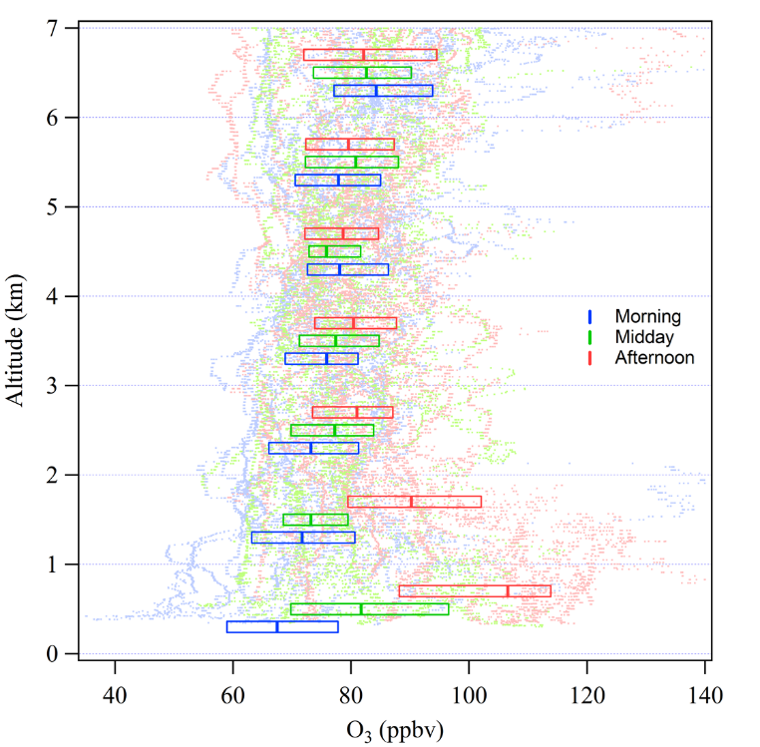

Figure 2-4. Vertical distribution of ozone observed by the DC-8 during fifty-two profiles conducted in the vicinity of the Taehwa Research Forest southeast of Seoul. Boxes showing median and inner quartile values for 1 km increments of altitude are plotted over the individual measurements. (Figure provided by Jason Schroeder, NASA)

Figure 2-4 shows that ozone in the free troposphere over SMA during KORUS-AQ was persistently greater than 60 ppbv. The influence of local emissions and photochemistry on ozone is clear in the lowest 2 km where it is observed to increase from morning to afternoon. However, just above at 2-3 km altitude, there is a reservoir of ozone with median values of 75-80 ppbv that does not vary with time of day. This reservoir is not expected to influence extreme ozone events, but as average ozone from photochemical production decreases in the boundary layer over Korea, downward mixing from this reservoir would pose a challenge to meeting the 60 ppbv 8-hour standard. Reductions in ozone aloft will depend on larger regional efforts across Asia and the northern hemisphere; thus, continued observations of ozone aloft over SMA are necessary for assessing the effectiveness of local control strategies in the context of influences from the greater regional and northern hemispheric background.

**Question 3: How well do KORUS-AQ observations support current emissions estimates (e.g., NOx, VOCs, SO2, NH3) by magnitude and sector?**

**Summary Finding: KORUS-AQ observations indicate that emissions in Korea are underestimated based on comparisons with model predictions using current emissions estimates. Further evidence comes from sampling in proximity to specific point sources where observed concentrations exceeded values expected based on reported emissions.**

Emissions are a critical component of air quality models that deserve constant attention. They exhibit complex variations on daily, seasonal, and annual scales. Even when based on the best knowledge, field observations are needed to assess their accuracy. Discrepancies are common, particularly on the side of underestimation. Using the KORUS-AQ observations to assess and improve emissions is critical to understand the relationship between current emissions and air quality conditions and effectively predict what might be expected from further strategies to reduce emissions.

Figure 3-1 shows a comparison between DC-8 observations and predictions from several models for aromatic VOCs and NOx. There is substantial disagreement between the models, but all models consistently fall below observations, indicating that the strength of emissions is an important discrepancy affecting these models. This discrepancy will further influence the magnitude of predicted impacts on PM2.5 and ozone.

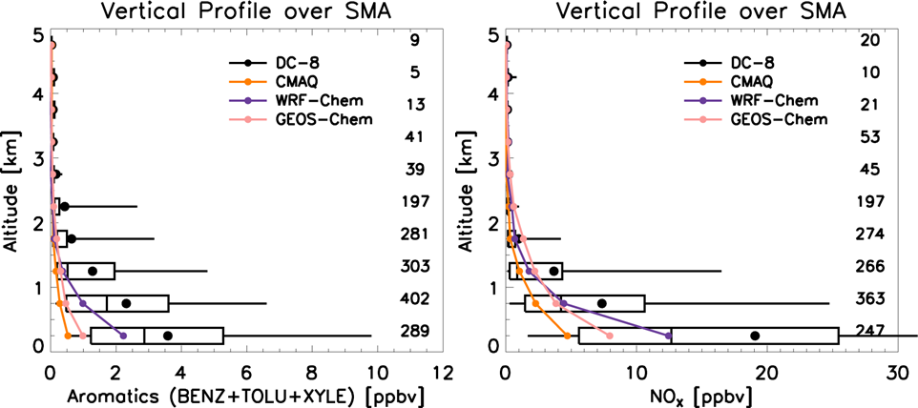

Figure 3-1. Comparison of DC-8 observations with model simulations for aromatic VOCs (left) and NOx (right) in the lower atmosphere over Seoul during KORUS-AQ.

(Figure provided by Rokjin Park, Seoul National University)

The detailed ground observations at Olympic Park provide additional clues to the reasons for these underestimates. As shown in figure 3-2, differences between observations and models vary substantially from day to day. This variability as it relates to transport patterns, chemistry, and daily changes to emissions due to weekdays, weekends, and holidays will be the subject of ongoing KORUS-AQ analyses. Advanced techniques such as inverse modeling will also be used to identify the most likely causes for underestimation.

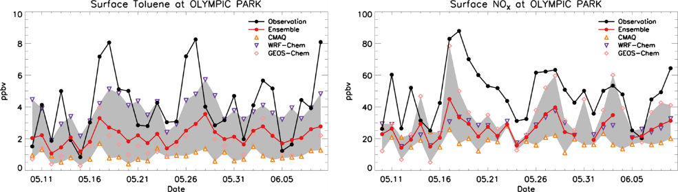

Figure 3-2. Comparison of observations with model simulations for Toluene (left) and NOx (right) at the Olympic Park site during KORUS-AQ. (Figure provided by Rokjin Park, Seoul National University)

The underestimation of toluene and other aromatic compounds is a major contributor to poor agreement between models and observations due to their reactivity and collective contribution to the pollution chemistry of the SMA. Figure 3-3 provides a reactivity weighted speciation of VOC observations from the DC-8 which shows the dominant role of aromatics.

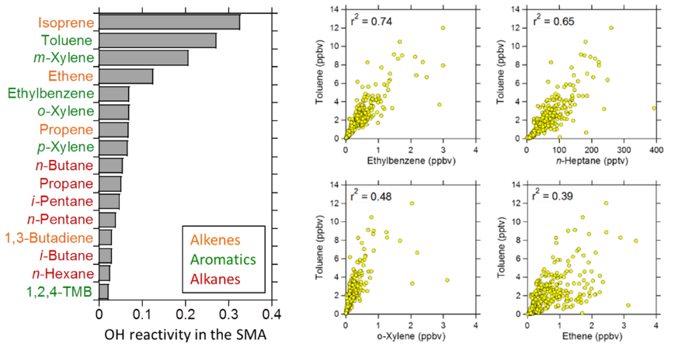

Figure 3-3. Relative importance of VOCs observed in SMA based on their contribution to OH reactivity (left) and VOC correlations useful for determining likely sources (right). (Figure provided by Isobel Simpson, University of California, Irvine)

The most likely source of the aromatic compounds is solvent use; however, more work is needed to attribute specific sources. For instance, previous work in Hong Kong suggests that strong correlation of toluene with ethylbenzene and xylenes indicate architectural paints. Additional correlations with benzene, n-hexane, and n-heptane indicate consumer products and printing. Correlation with ethane, propene, etc. indicate vehicular exhaust. Applying these relationships (see Figure 3-3), early analysis shows that toluene correlates poorly with traffic tracers such as ethene and propene. Multiple solvent sources are suggested by stronger correlations with ethylbenzene, n-hexane, and n-heptane. Weaker toluene correlations with xylenes raise the possibility of additional xylene sources. For instance, xylenes dry more slowly than toluene and may be associated with different solvent applications. Finalization of observations and further analysis of data from the DC-8 and other ground sites are needed to make more definitive conclusions on aromatic sources.

In contrast to the underestimation of NOx and VOCs, models do not consistently underestimate SO2, indicating that emissions are well represented or possibly even overestimated (see Figure 3-4). Another difference is that in comparison to NOx and VOCs, a much larger portion of SO2 emissions comes from point sources, such as power plants.

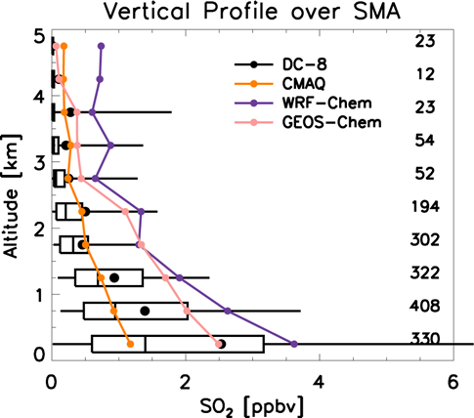

Figure 3-4. Comparison of DC-8 observations with model simulations for SO2 in the lower atmosphere over Seoul during KORUS-AQ. (Figure provided by Rokjin Park, Seoul National University)

Direct sampling of point sources was accomplished during KORUS-AQ for a number of power plants and other facilities by both the NASA DC-8 and the Hanseo King Air. A preliminary assessment of these observations is ongoing to verify their emissions. Early results suggest that power plant emissions agree with aircraft observations but the uncertainties in the analysis are large, especially under conditions of light winds, and are undergoing further assessment. Other analyses have indicated that emissions from some facilities can be substantially larger than expected. Figure 3-5 shows how observations were collected for volatile organic compounds (VOCs) emitted from the Daesan Chemical Facility on 5 June 2016.

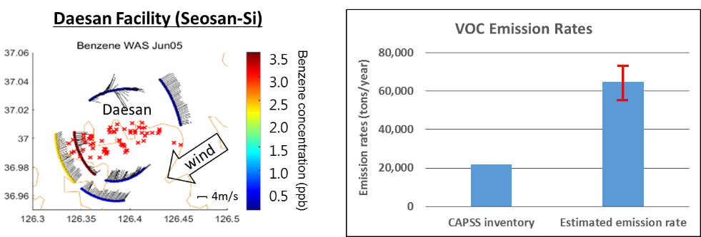

The estimated emission rates have been based on a mass balance approach taking the observed wind field and VOCs into account. It is important to note that CAPSS (Clean Air Quality Support System) inventory values are for the entire district. For Seosan-Si, inventory values are a factor of three lower than estimated from observations of the Daesan plume. Ongoing analysis of these plume observations is an important part of the emissions verification and assessment being conducted by the KORUS-AQ team of researchers.

Figure 3-5. Estimated VOC emissions from observations of the Daesan Chemical Facility (left). The estimate is compared to CAPSS inventory emissions for the entire Seosan-Si district (right). (Figure provided by Seokhan Jeong, GIST)

**Question 4: How significant is the impact of the large point sources along the west coast to the air quality of SMA temporally and spatially?**

**Summary Finding: Point source impacts appears to be stronger in the southern portion of the Seoul Metropolitan Area, but further verification of emissions are needed to improve the quantification of these impacts and translate them into contributions to fine particle pollution and ozone. For toxic substances, attention needs to be given to the health and safety of workers and populations in closer proximity to the facilities producing these emissions.**

During the KORUS-AQ study period, the wind direction in Seoul was often from the southwest where many point sources are located. In particular, five power plants along the coast and the Daesan Chemical Facility represent large point sources with the potential to have a substantial impact on Seoul and the greater SMA. As already discussed, these point sources were directly sampled by the DC-8 and Hanseo King Air and are undergoing further analysis to verify their emissions.

To examine the power plant contributions to NOx and SO2 across SMA, simulations using the CALPUFF model were conducted. The CALPUFF model simulates the transport and dilution of these emissions, which were based on the real time observations from the CleanSYS smokestack tele-monitoring system.

Figure 4-1 shows CALPUFF simulations of NOx and SO2 for several case studies during the KORUS-AQ period. Taean power plant stands out in these simulations as the dominant point source. While Daesan Chemical Facility is not included in these simulations, its proximity to the Taean power plant provides a reasonable approximation for transport of those emissions as well. These simulations indicate that the largest influence is on the southern portion of SMA with a smaller influence on Seoul. It is possible that these point source emissions are an additional factor contributing to the higher ozone levels recorded by AirKorea monitors in Gyeonggi as compared to Seoul.

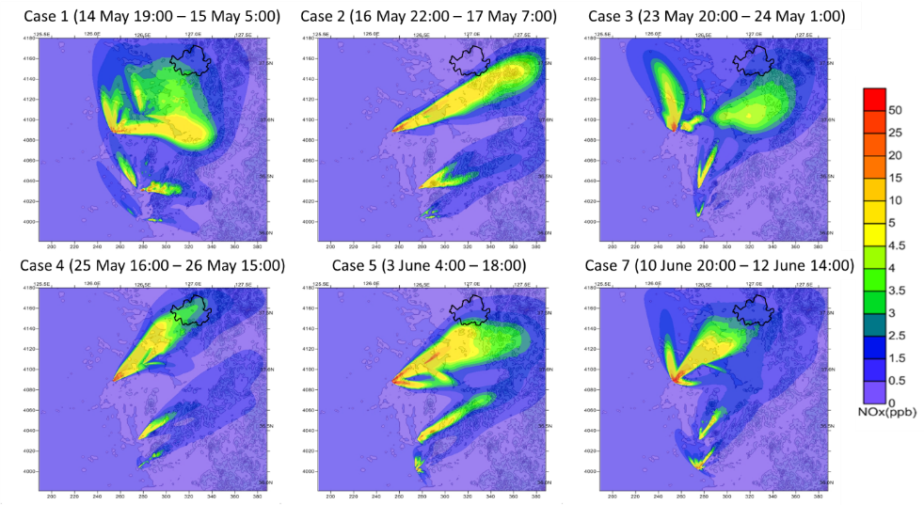

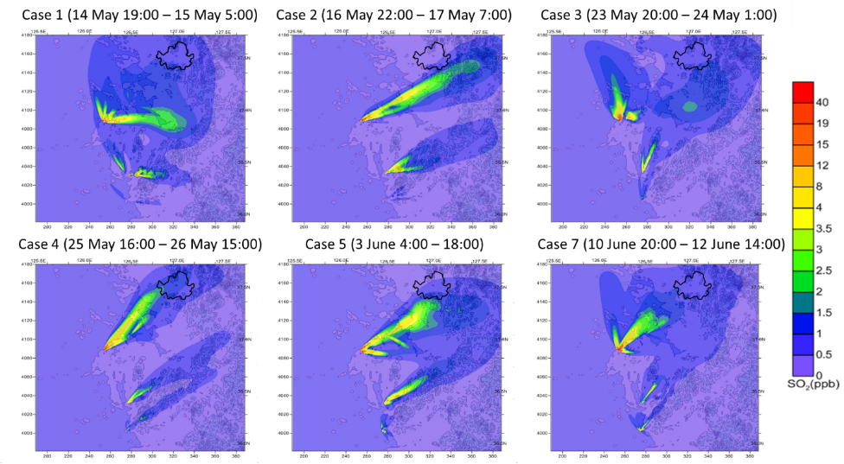

Figure 4-1. CALPUFF simulations of power plant emissions of NOx (top six panels) and SO2 (lower six panels) and their regional influence on selected days. The border of Seoul is outlined in black. (Figure provided by Joon-Young Ahn, NIER)

Sampling in close proximity to point sources revealed an additional concern related to toxic substances and exposures of workers and nearby populations. Figure 4-2 shows measured abundances of benzene and 1,3 butadiene during direct overflight of the Daesan Chemical Facility. These two substances are known carcinogens. Data are plotted by latitude to demonstrate that these plume values are orders of magnitude greater than regional average values. At least 25 VOCs showed their highest mixing ratios observed during KORUS-AQ in measurements over the Daesan facility. Since these are aircraft data, values on the ground are expected to be even greater. This raises concerns for potential long-term health effects for workers and residents living or frequently visiting areas near this facility. Such effects have been observed downwind of other industrial sites in Canada, the United States, and Sweden that emit benzene and 1,3-butadiene.

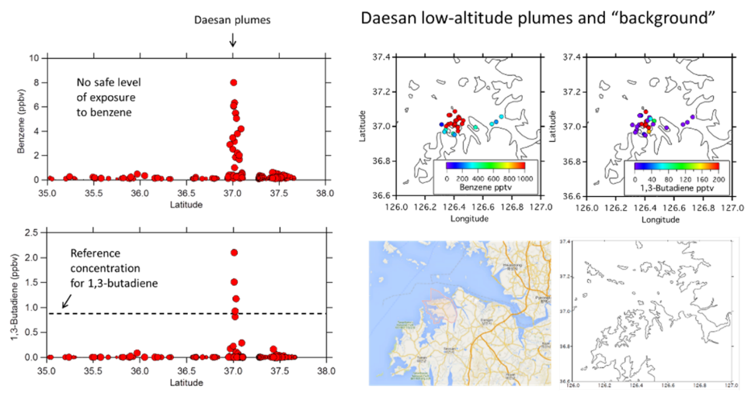

Figure 4-2. Measurements of benzene and 1,3-butadiene during overflight of the Daesan Chemical Facility. Observations versus latitude are shown on the left with the plume over Daesan evident at ~37N. Maps on the right show the geographic location of plume observations. (Figure provided by Isobel Simpson, University of California-Irvine).

**Question 5: How is Seoul affected by transport of air pollution from sources from regional to continental to hemispheric scales?**

**Summary Finding: Fine-scale local meteorology can lead to very abrupt changes in air quality across SMA that are difficult to forecast and deserve attention. Long-range transport was not a major influence during most of KORUS-AQ, but PM2.5 did maximize during the short period of direct transport from China. Models are necessary to estimate the apportionment of local versus transported particle pollution, but detailed analysis of model results in comparison to observations are needed to verify model results.**

Seoul is affected by transport on many scales: local to regional to hemispheric. The land-sea breezes and the complex topography around Seoul can influence pollution distributions on very short time scales. An example is provided in Figure 5-1. On May 19-20, a frontal passage caused large, rapid changes in ozone and black carbon amounts measured at the central observatory located in Bangi-dong, southeastern Seoul (Olympic Park). At two different times, ozone changed by almost 40 ppbv within 5 minutes. This shows the rapid shift of air pollutants via strong land and sea winds. Similar changes in ozone can be seen migrating from west to east in high resolution data from the AirKorea network on this day. This demonstrates the value of retaining AirKorea data at finer temporal scales than 1-hour averages to learn more about these episodes and their predictability. Such information would be essential for evaluating air quality forecasts using fine scale models specifically designed for the topography and meteorology of SMA.

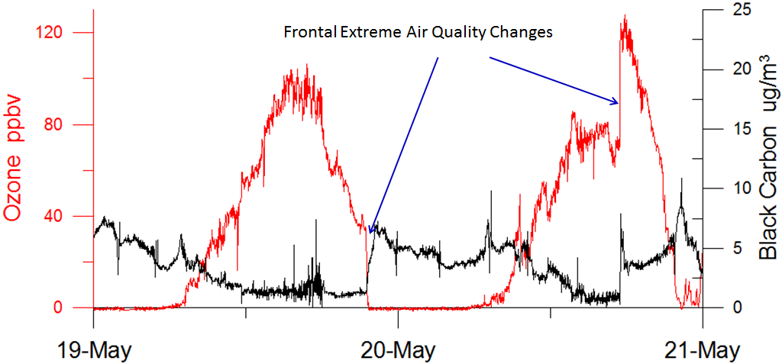

Figure 5-1. Rapid concentration changes in ozone and black carbon measured from the observatory in Olympic Park, 19-20 May 2016. (Figure provided by Gangwoong Lee, HUFS)

During the period of May 25-28, the concentration of aerosol surpassed the Korean AQ standard coincident with strong transport from China. The meteorology of this period and the preceding period of stagnation over Korea are depicted in Figure 3 of the Introduction. Figure 5-2 shows the behavior of PM2.5 and ozone during these two periods. While there is no obvious difference in ozone, PM2.5 roughly doubles during the period of direct transport from China and stands out as the most significant period of fine particle pollution during the KORUS-AQ study.

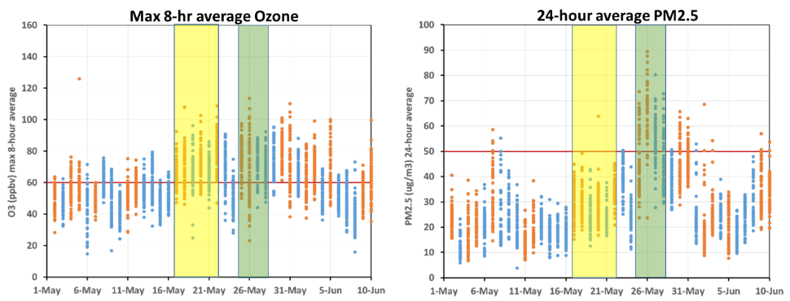

Figure 5-2. Observations of O3 and PM2.5 from selected AirKorea monitors in Seoul, Busan, and Gwangju during the KORUS-AQ field study period of 1 May-10 June 2016. Observed values across individual ground sites on each day are compared with Korean air quality standards. Days of airborne data collection are shown in orange showing that flight days adequately sample the range of air quality conditions. Two periods are highlighted to draw specific attention to a period of stagnation (yellow) and a period of direct transport influence from China (green). (Figure provided by Jim Crawford, NASA)

Direct evidence for this transport influence is shown in Figure 5-3. GOCI satellite aerosol optical depth (AOD) is shown in the left panel where very high values are observed to the west of Korea. The lack of direct observations over the Korean peninsula is related to cloudiness associated with the transport. Enhanced cloudiness during transport events poses a particular challenge to satellite observations and serve as a reminder that such observations must be supplemented by information from other sources, such as ground and in situ aircraft observations and model simulations. The right panel shows this type of supplemental information from the High Spectral Resolution Lidar (HSRL) onboard the DC-8 aircraft. Looking at the profile of aerosol extinction compared to the average for the full KORUS-AQ study corroborates the large enhancement in PM2.5 values seen across the AirKorea network during this period. An important caveat on relating AOD from satellites or lidar observations to PM2.5 is the influence of humidity. High humidity will cause aerosol size to increase, thus leading to greater scattering and higher AOD for a given aerosol amount. PM2.5 measurements are for dry aerosol, so AOD differences can be greater than the differences observed for PM2.5 due to these effects.

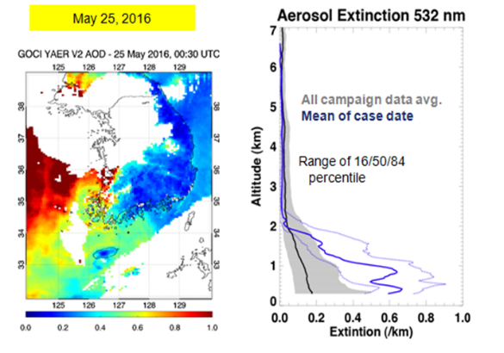

Figure 5-3. Satellite AOD from GOCI (left) and HSRL aerosol extinction (right) observed from the NASA DC-8 on 25 May 2016. (Figure provided by Jhoon Kim, Yonsei University)

Model simulations of PM2.5 throughout the KORUS-AQ study period and the estimated regional contributions to aerosol composition are shown in Figure 5-4. With the exception of 5/20-5/23, the model adequately predicts the abundance of PM2.5. Based on this simulation, it is estimated that roughly half of the fine particulate pollution during this time period was of local origin. In terms of components, long-range transport showed higher contribution rates of SO2, with roughly equal portions of local versus external contributions for organic, nitrate, and ammonium aerosol. Local contributions were found to be dominant for black carbon. An important ongoing activity is a detailed comparison of results from the model shown in figure 5-4 as well as other models with the KORUS-AQ observations. For instance, measurements of aerosol composition at Olympic Park showed the highest fraction of nitrate aerosol during the transport period (25-28 May). This raises the question of whether local aerosol production was also enhanced during the transport period. This is a topic warranting further investigation since it is important to know whether the local aerosol production in the absence of transport provide an adequate estimate of the contribution from local sources.

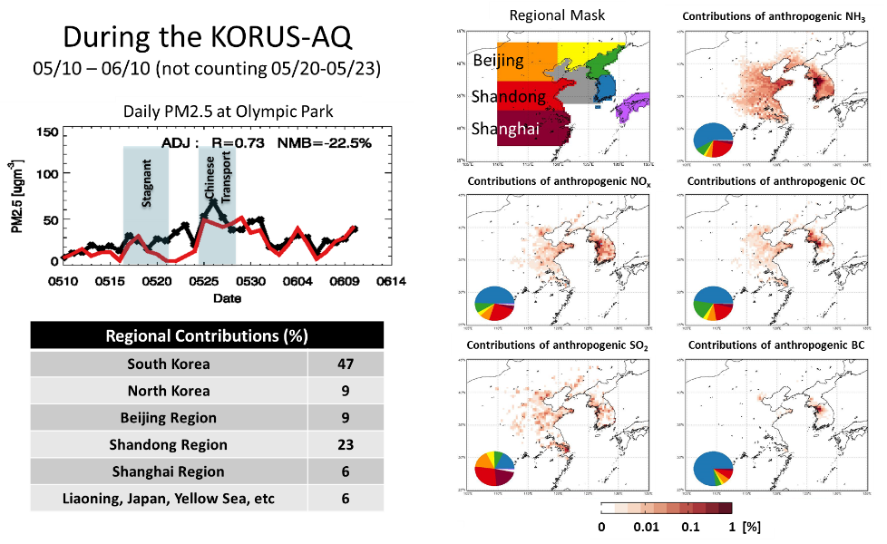

Figure 5-4. Comparison of model predictions of PM2.5 (red line) and observations (black line) at Olympic Park (top left) and integrated contributions (lower left) estimated for the KORUS-AQ study period. Tagged contributions to PM2.5 composition by component are shown in the panels on the right. (Figure provided by Rokjin Park, Seoul National University)

**Summary and Recommendations**

1. **Reducing emissions of NOx and VOCs, particularly aromatics such as toluene, will reduce formation of both fine particle and ozone pollution.** Observations of fine particle pollution in the free troposphere and at ground level has shown that the organic and nitrate components account for roughly half of the particulate pollution. Ozone formation in Seoul appears to be VOC-limited, with aromatics making a disproportionate contribution, thus reductions in these compounds will reduce ozone formation in Seoul. However, the high emissions of NOx in and near Seoul, from vehicles and power plants, lead to ozone production across a much broader region. Limiting the area over which ozone is produced can only be accomplished by NOx reductions. As reductions are implemented, the nonlinear chemistry of ozone production will still enable small areas of increased production despite overall regional improvement.
2. **Emissions inventories must be further evaluated and improved to allow for accurate air quality modeling to be performed.** Ongoing analysis of KORUS-AQ observations will be useful in this regard. Modeling, if using accurate emissions, allows for source attribution to air quality problems and determination of optimal emissions control strategies. Identification and quantification of the sources of aromatics and other specific VOCs in and around Seoul are needed. Emissions of NOx and SO2 from power plants need to be verified and improved if necessary. Ammonia is sufficiently abundant to neutralize aerosol sulfate and nitrate and its sources should be quantified to understand how important it is to secondary aerosol formation rates.
3. **Point source impacts on ozone and fine particle pollution are strongest in the southern portion of SMA, and there are also localized impacts of toxic compounds that need to be addressed.** As noted above, verification of emissions from point sources is an important step to quantifying their impact. Airborne observations near Daesan chemical facility revealed dangerous levels of carcinogenic compounds. More detailed fenceline observations are needed at this and other facilities to understand exposures for workers as well as local populations living, working, or recreating nearby.
4. **The impact of sources outside Korea varies greatly with season and requires further study.** Much of the KORUS-AQ study period was characterized by meteorology preventing direct transport from East Asia. The benefit of this was to isolate and focus attention on the contribution of local emissions and the resulting magnitude of fine particulate and ozone pollution. However, further understanding of polluted conditions during other seasons is still needed. With the enhanced capability of Korean researchers to perform independent observations after KORUS-AQ, further intensive observations in the winter and spring seasons of 2018 are highly desirable. The Korean research community is also in a strong position to pursue collaborative research with Chinese scientists, which will enable more definitive studies of long-range transport effects. This could include expansion of collaborative research between NIER and the Chinese Academy of Sciences, as well as Korean-led air quality joint research projects in East Asia, such as LTP and NEASPEC.