ASIA-AQ
All Hands Telecon
Tuesday, December 12, 2023

NOTES

Mission Updates (Jim Crawford)
- Malaysia: had a nice call with the Embassy, items moving forward as expected; the Cabinet paper will be the last item to clear
- Thailand: there is scheduled meeting tomorrow pm; we are working hard to move flight patterns forward; agreements are moving forward
- Taiwan: Thursday pm call feeling positive that loose ends will be tied up
- AMA: has been reaching out to participants; please be patient they are new
- Philippines: MOU not signed yet as there are a few lines under scrutiny; we should regard this as 100% destination

QNC Flight Seats (Jack Dibbs)
- All seats on the transit flights are taken
- There continues to be some shuffling with test flights – nothing major
- 2 science seats open on the CA to Philippines leg
- 1 seat open on the transit back through Alaska
- Wednesday deadline for open seats – speak now or seats will be returned to AFRC folks

Registration and Lodging (Judy Alfter)
- Keep your registration up to date
- New lodging venues:
  - Philippines: please book by Friday, 12/15
  - Thailand: check the website this is a new listing
  - S. Korea: Turumi Lodge – ESPO will book based upon registration information
- Each lodging venue has their own reservation method – see ESPO website
- How quickly can folks get reimbursed by AMA? JZ will follow up.
- For Grads and Post-Docs, reach out to Jim C. and he will plead the case for speedy processing of your travel expenses

G-III Updates (Pat Bookey)
- No changes to aircraft
- On track for 1/11 upload

DC-8 Updates (Brian Hobbs)
- Integration running smoothly

AFRC Integration (Tyler Keppel, Brian Hobbs)
- Going smoothly
- Finalizing pressure systems with instrument teams this week
  - There are a few teams that need to get with Wong

Stoplight Chart (Tyler Keppel)
- No updates on stoplight chart

Air and Sea Shipment Plan (JZ)
- 12/22 Air Shipment departs AFRC to Philippines
  - Toolsets and spares (TS-1)
- 1/28 bunch of separate shipments going to Korea
- 2/14 Philippines to Malaysia (TS-1)
- 2/27 Korea to Thailand (TS-2)
- Instrument teams should be pro-actively working on items
- No lithium batteries, chemicals, or other hazmat
- AFRC will set up designated areas for equipment, label your instrument name, destination, ask Alberto if you have questions
- Early January 1 hazmat shipment to Thailand
- Still tracking shipment from Langley to Korea
- ESPO received first shipment; contact Andrian Liem, Sommer Nicholas or Jhony Zavaleta if your instrument team is not listed

Basing Locations (JZ)
- Philippines: arrival airports are CRK (10 minutes to hotel), and MNL (3.5 hours to hotel); per diem rate=Clark; Ops Center will be Clark International Airport
- S. Korea: arrival airport is ICN (1.5 hours to Osan); per diem rate=Pyeongtaek; Ops Center will be Osan AB
- Malaysia: arrival airport is KUL (45 minutes to hotel); per diem rate=Subang; Ops Center will be Sultan Abdul Aziz Shah Airport
- Thailand: arrival airport is BKK (1.5 hours to hotel); per diem rate=Pattaya; Ops Center will be U-Tapao Rayong Airport

Transportation Plans & Coordination (JZ)
- Car rentals: One-way rentals to Palmdale available; AFRC and ESPO can help with shuttle day before transit flights; Uber or taxi also an option
- Transpiration to hotels: Philippines, S. Korea, Malaysia, and Thailand: ESPO working on shuttles for these locations; upcoming Deployment Guides will include additional transport info
- Transportation at deployment sites: no car rentals allowed; ESPO will coordinate shuttles between airports and hotels
- Deployment guide will give additional information – will be available early 2024

Instrument Readiness Outlook for Test Flights
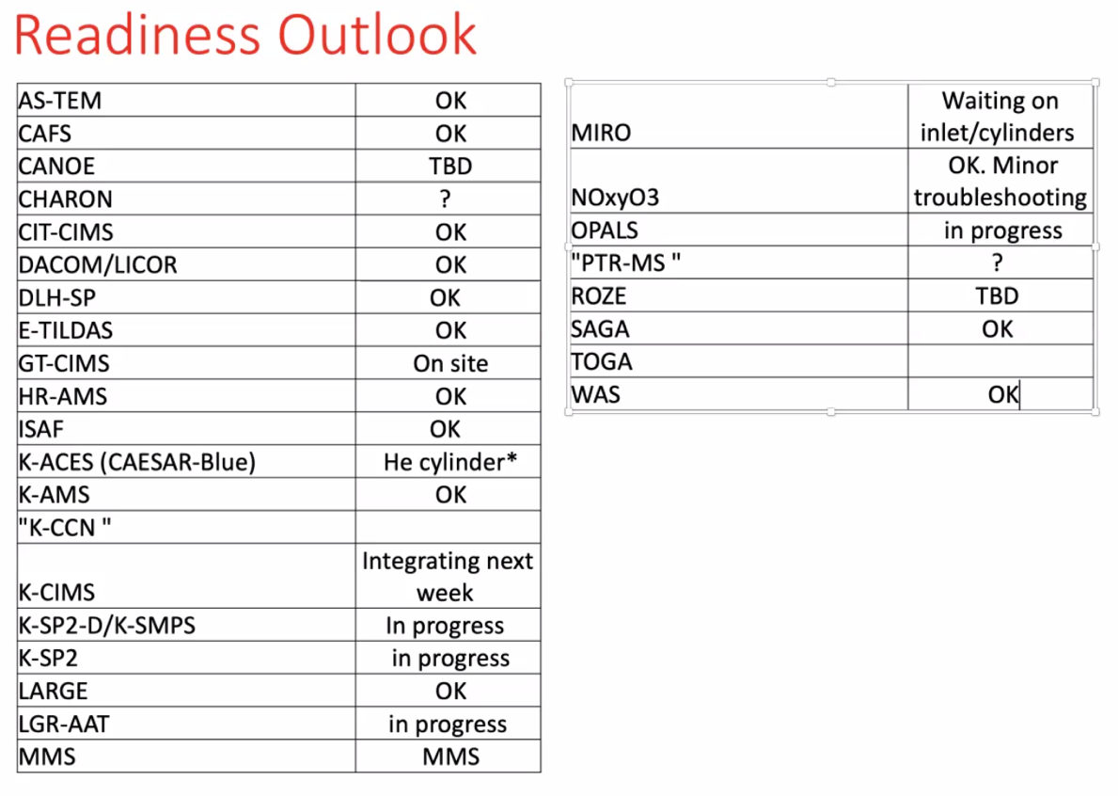

Field Work (Tyler Keppel)
- Going smoothly

Other
- AMA travel: no advances given; possible for direct billing by AMA on your behalf (Grad Students)
- Badging: please upload your photos
- G-3, DC-8 Fire Watch: they will be parked in proximity of one another. Teams will communicate for any collaborative efforts. Teams will explore crowdsourcing.
- DC-8 Transit flyers will require a room in Alaska and Korea for 1/30 both locations
- Will there be extra access in early January at AFRC? No.

