**Bulk Import mailing list members from sync list – Step by step**

**Step: 1**

Received an email as shown below

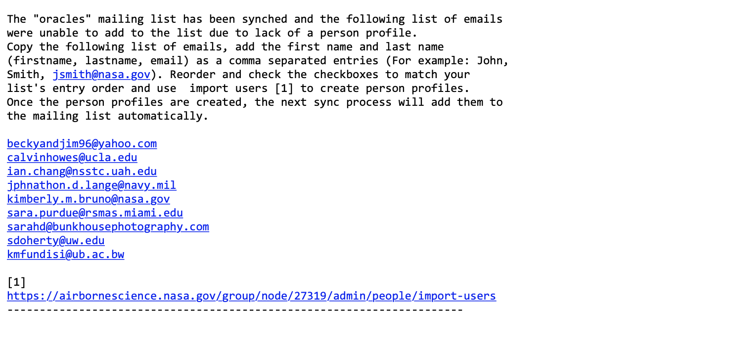

URL to bulk import

List of emails

**Step: 2**

Create a list from the members using the “List of emails” listed in the email by adding first name and last name. For example:

Calvin, Howes, [calvinhowes@ucla.edu](mailto:calvinhowes@ucla.edu)

Ian, chang, [ian.chang@nsstc.uah.edu](mailto:ian.chang@nsstc.uah.edu)

**Step: 3**

Go to the Bulk import page by clicking the link provided in the email as show in Step 1.

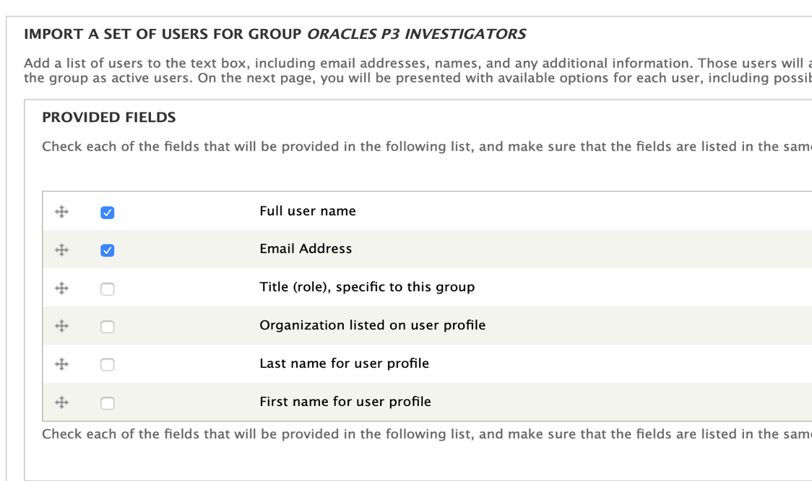

**Step: 4**

Make sure the fields are ordered and checked as shown below. You can drag them to reorder.

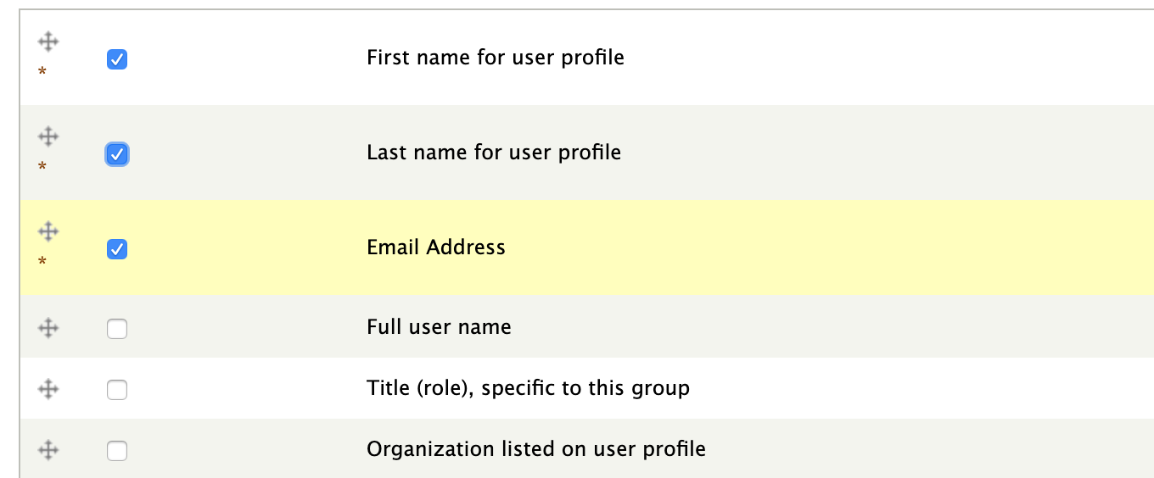

**Step: 5**

Make sure the you select the separator as "comma"

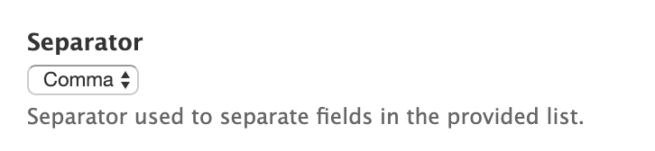

**Step: 6**

Paste the List of firstname, lastname, email into the "List of users" field.

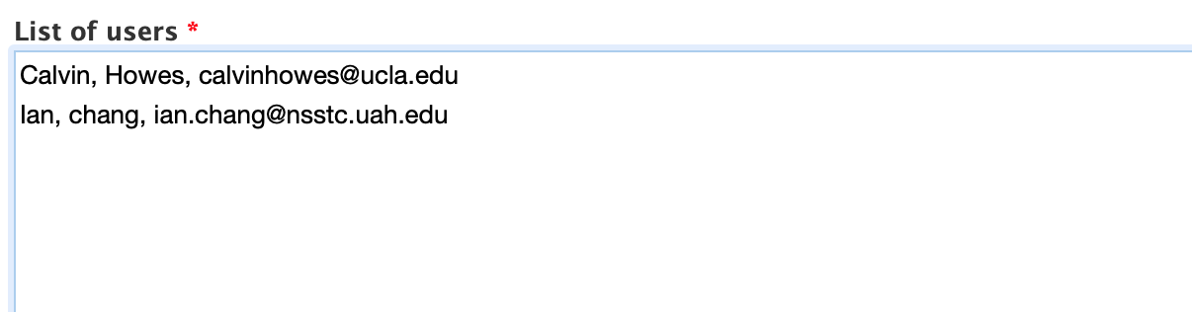

**Step: 7**

Click the "Process user List"

**Step: 8**

You should see something like the screenshot below. **This is where you have to make sure if this person already has a profile or a new profile need to be created and check the appropriate button**. The system will guess and provide you with possible existing profile match(es). Once you verify all the user in your list, click "Add User" button.

