|  |  |  |  |
| --- | --- | --- | --- |
|  | **Science Directorate (Code S)**  Ames Quality Management System |  | Date  04.19.2019 |
| Title: **Organizational Plan Profile** | | |  |

1. **ARC Code: S**
2. **Title: Science Directorate**
3. **Organization Purpose & Description**

The ARC Science Directorate (Code S, hereafter “The Directorate”) conducts basic and applied research, and technology development aligned with the tri-annual NASA Strategic Plan, and with the derived NASA Science Plan. The Directorate’s activities are in support of the Agency’s astrobiology, astrophysics, planetary sciences, biological sciences and Earth science programs. The Directorate seeks to discover new insights and to better understand the mechanisms, phenomena and interactions that exist within and among living and non-living things in the universe. The Directorate provides scientific leadership for NASA flight projects/programs, provides management of Earth science airborne campaigns, and builds and delivers dozens of flight payloads to the International Space Station. The Directorate also hosts the NASA Mars Climate Modeling Center and the NASA Earth Exchange.

The Directorate is home to more than 150 civil servants, the majority of whom are research scientists or engineers. The government staff is augmented by approximately 300 contractor scientists and engineers, support staff, postdoctoral fellows, and students. The Directorate is organized into three Divisions: Space Biology (Code SC), Earth Science (Code SG), and Space Science and Astrobiology (Code SS).

1. **Organization Chart**

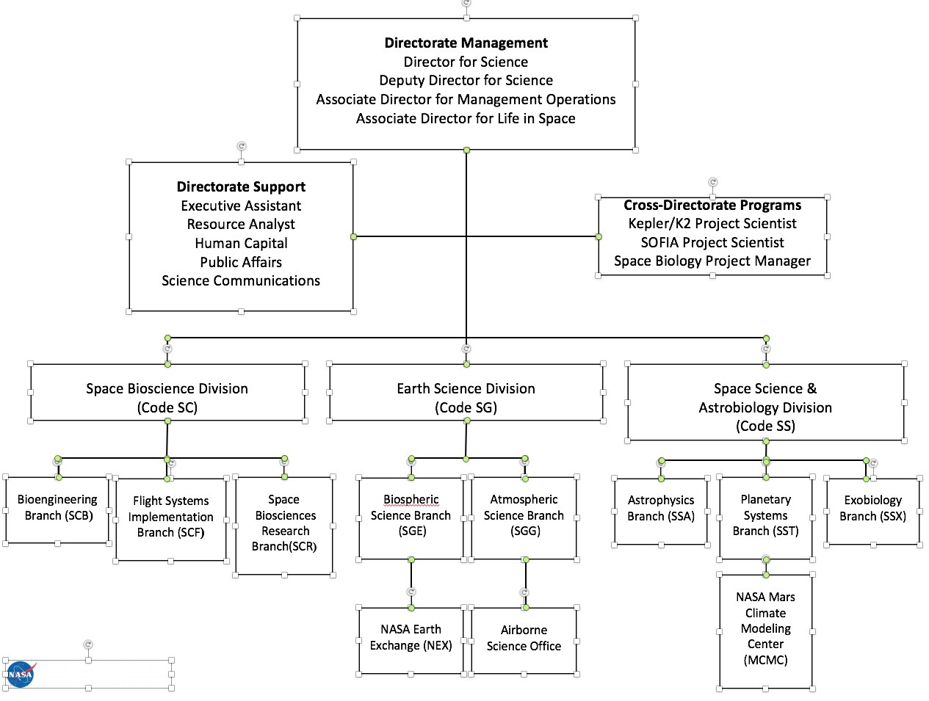

1. **Roles and Responsibilities**

EARTH SCIENCE DIVISION

The Earth Science Division (Code SG) supports NASA's goals in Earth Science through a robust program of research and technology development in atmospheric and biospheric sciences. The Division has a long heritage of excellence in defining and managing airborne science mission campaigns for NASA, often with the participation of other federal agencies and academia. Individual researchers and engineers design and develop payloads that often fly on these campaigns, and are responsible for the successful science operations and data analysis of those instruments. The airborne data advances scientific understanding through the merging of airborne with satellite-based observations, numerical modeling, laboratory studies, instrumentation and information systems development to further the knowledge of our home planet. The Earth Science Division has the Agency lead, through the Earth Science Project Office (ESPO), of managing NASA's major Earth science field campaigns, which span the globe, are multi-center, multi-agency and often conducted with international partners. The Division applies the knowledge gained from Earth science research to applications for societal benefit, and maintains a program of education outreach. Key components of the Division’s research programs include the study of the physical and chemical processes of biogeochemical cycling; the dynamics of terrestrial ecosystems; the chemical and transport processes that determine atmospheric composition, dynamics, and climate; and the physical processes that determine the behavior of the atmosphere on the earth and other solar system bodies.

1. **Products and Services**
2. **Delegated Authority**
3. **Policies Owned by the Organization**
4. **Organization Charters and Boards**
5. **Organization-Managed Processes & Work Instructions**

The Directorate has identified appropriate oversight and evaluation processes for managing flight projects that satisfy two conditions: (i) not subject to NPR 7120.5, and (ii) life-cycle costs less than ten million dollars. [Larger programs are traditionally managed at the Center through the Program and Projects Directorate (Code P).]

**Role Process/Work Instruction**

Earth Science Projects Office Management of Agency airborne and sea-based Earth Science campaigns

ISS Projects Design, development and project management for *International Space Station* experiments and payloads

Space Biology Project Management and advocacy for Agency fundamental space biology projects/programs

**10.1 Earth Science Campaigns**

The Directorate manages NASA airborne and sea-borne Earth Science campaigns through the Earth Science Projects Office (ESPO), acting as an agent for HQ/SMD/Earth Science Division.

**10.1.1 Work Practices**

When a project is assigned to ESPO, the ESPO Director assigns a Project Manager (PM), deputy Project Manager and support team. The project team is responsive to requirements and adheres to the constraints in NPR 7120.8. The ESPO team has a “Project Management Guide” that has the steps needed to successfully implement a field project and sample documents (site visit reports, project plans, presentations etc.). Lessons learned are added to the guide after each project. The ESPO team has a folder, for internal use, on the NASA Google drive to maintain and share documents, including the Project Management Guide. Project teams meet on a regular basis to work issues, communicate information, and maintain a project website with project-specific information. The ESPO team meets weekly to go over issues, concerns and lessons learned across projects.

**10.1.2 Oversight**

Earth Venture - Suborbital (EV-S) projects follow a formal review process (Investigation Concept Review, Midterm reviews, KDP-F etc.) overseen by the Earth Systems Science Pathfinder Program office at NASA’s Langley Research Center. The multi-aircraft projects conduct a Mission Readiness Review prior to deployment for the Airborne Science Program Director and the appropriate Program Manager(s) at HQ/SMD.

**10.1.3 Stakeholder Feedback**

The ESPO Director meets with each PM on a regular basis to maintain oversight and provide guidance. The PM works with the HQ/SMD Program Manager for the project and the Director receives informal feedback from the scientists, aircraft and Program Manager during and after the mission. The project participants can provide feedback through the Customer Feedback form on the airborne science website.

1. **Organization Lateral Relationships**

**12. Reporting Relationships**

**13. External Relationships**

**14. Customer Satisfaction Feedback**

**15. Management Objectives and Metrics**

**16. Continuous Improvement Action System**

**17. Document Control System**